**December, 2018**



**Immersion Day**

Serverless Data Lake with AWS

# Table of Contents

Table of Contents 2

Revision History 3

Disclaimer 3

Lab Pre-Requisites 4

Section II - Data Processing Layer 4

Lab 2.1 - Cataloging a Data Source with AWS Glue 4

Lab 2.2 - Transforming a Data Source with Glue 9

Lab 2.3 - Advanced Data Preparation with Glue Developer Endpoints and Notebook 17

Lab 2.3.1 Create a Developer Endpoint: 17

Lab 2.3.2 Create a Jupyter Notebook for Interactive Advanced Data Manipulations 19

Lab 2.3.1 Automating ETL Tasks with Triggers 26

Summary & Next Steps 30

Deleting Lab Resources 30

Appendix A – Jupyter Notebook Code 31

References 33

# Revision History

|  |  |  |  |
| --- | --- | --- | --- |
| Revision | Date | By | Change Log |
| PA6 | 03-Dec-2018 | @akirmak | First 3 labs reer reviewed by @baya |
| PA7 | 13-Dec-2018 | @akirmak | Initial draft, ready for internal joint review. |
| PA8 | 14-Dec-2018 | @akirmak | Joint reviewed by @halilb and @serdarn |
| PA9 | 16-Dec-2018 | @akirmak | Joint review feedback incorporated. Fixed an error in Lab 2.4 instructions. Shortened Lab 3.1 |

# Disclaimer

The work is provided “as is” without warranties or conditions of any kind, either express or implied, including warranties.

# Lab Pre-Requisites

You need to complete Lab 1. If you haven’t performed Lab 1, and would like to work on a different dataset, you can still follow the instructions in this lab, but you may need to change steps slightly (e.g. S3 path, IAM role etc.)

For Lab 3, the iPython Notebook file to be used can be downloaded from AWS Workdocs [here](https://amazon.awsapps.com/workdocs/index.html#/document/3dfd7acc1e553e9885d49fa426b5dd44ecd48552e1bcc9da0104ca04e2b50182) (Ask your instructor if you cannot access the link).

# Section II - Data Processing Layer

# Lab 2.1 - Cataloging a Data Source with AWS Glue

To create your data lake, you need to catalog this data.

In this lab, you will use AWS Glue Data Catalog as an index to the location, schema, and runtime metrics of your data. You will also use the AWS Glue console to discover data, transform it, and make it available for search and querying.

**AWS Glue** is a fully managed ETL (extract, transform, and load) service that makes it simple and cost-effective to categorize your data, clean it, enrich it, and move it reliably between various data stores.

**Why AWS Glue?**

Given that the alternative would be to run distributed systems [Spark](https://spark.apache.org/) yourself, you can stay on the shoulders of the giant AWS infrastructure and let them manage it for you.

AWS Glue concepts used in this lab:

* **Data Catalog**: The AWS Glue Data Catalog is your persistent metadata store. It is a managed service that lets you store, annotate, and share metadata in the AWS Cloud in the same way you would in an Apache Hive metastore. You can access your data using various AWS services such as Athena, EMR and still maintain a unified view of your data using the AWS Glue Data Catalog.
* **Crawlers**: AWS Glue also lets you set up crawlers that can scan data in all kinds of repositories, classify it, extract schema information from it, and store the metadata automatically in the AWS Glue Data Catalog. From there it can be used to guide ETL operations.

1. Catalog data generated by KDG using a crawler that connects to the data store (S3 in this case), determines the data structures, and writes tables into the Data Catalog. In this lab, you will run your crawler on-demand. Use the AWS Glue console to create a table in the AWS Glue Data Catalog.

* Select Add Crawler
* Crawler Info step:
  + Create a new crawler to infer the data structure with name: **<your initials>-tame-bda-immersion-gc**
* Data Store step:
  + Select the source S3 bucket you created: **<your initials>-tame-bda-immersion**
  + Select: Choose **“raw”** subfolder
  + Fort he question: Select another datastore? Leave default answer: **No**
* IAM role step:
  + Choose IAM role: select **Choose** **existing IAM role.** The Cloudformation Template created an IAM role with a name like **sdlimmersion-tameGlueRoleSlessDataLakeImmersion-<UNIQUE ID>**

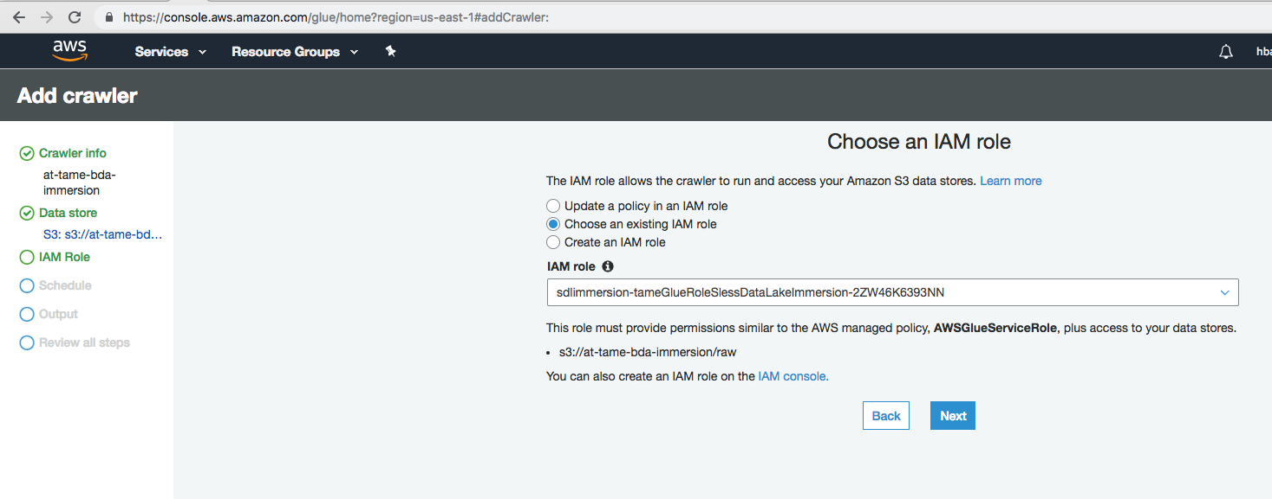

* Schedule Step:
  + Frequency: Choose “**Run on demand”**
* Output Step:
  + Select “Add Database”
  + Enter output DB name: **<your initials>-tame-bda-immersion-gdb**
  + Do not add any prefix, and leave default configuration options unchanged.

1. Select the new crawler and choose “Run”

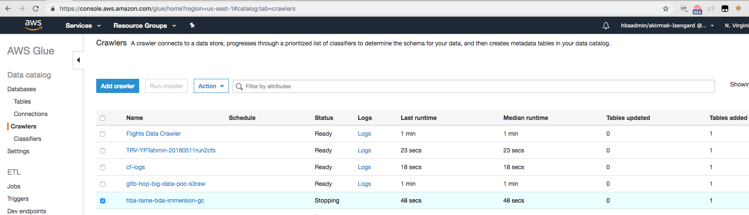

1. Select the new crawler and choose “Run”. After a few minutes, the crawler finishes, and the database and a table caller “raw” under the database shall be populated:

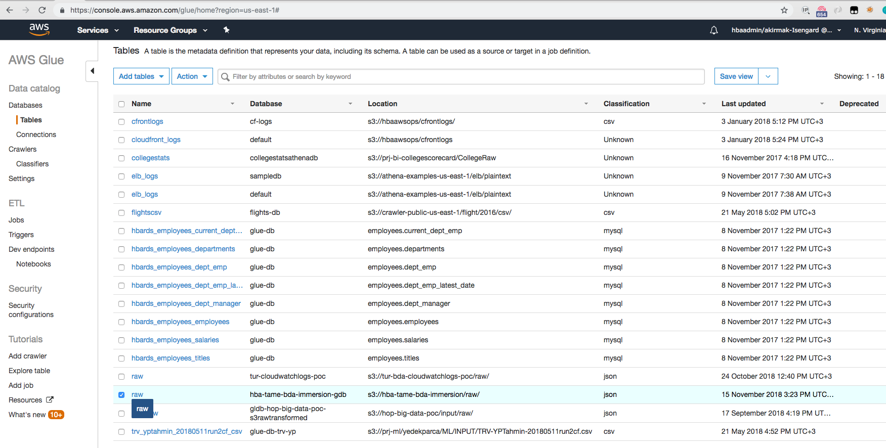

1. Select table and review the Table Design. The data format is correctly identified as JSON.

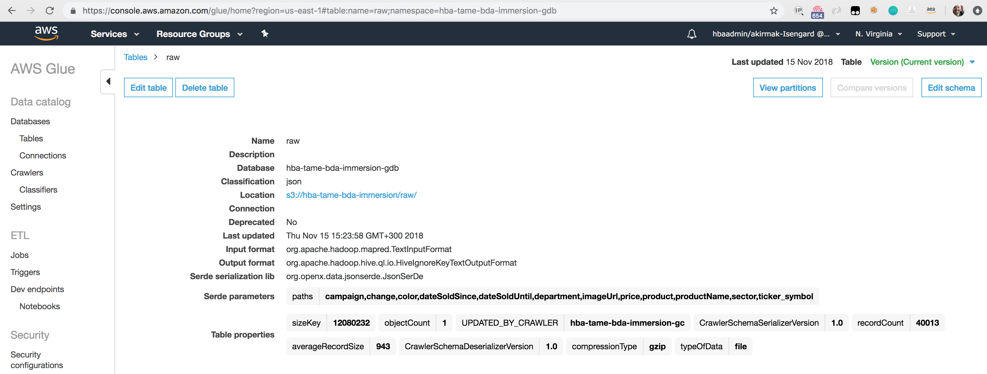

1. Review Schema. 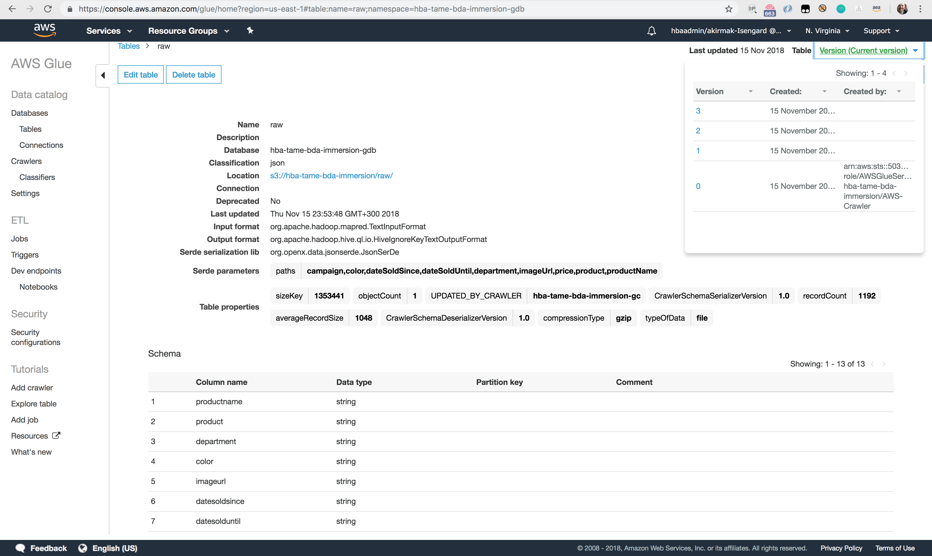
2. Edit the schema by renaming the partitions to correct values:
   * Partition_0 -> year
   * Partition_1 -> month
   * Partition_2 -> day
   * Partition_3 -> day

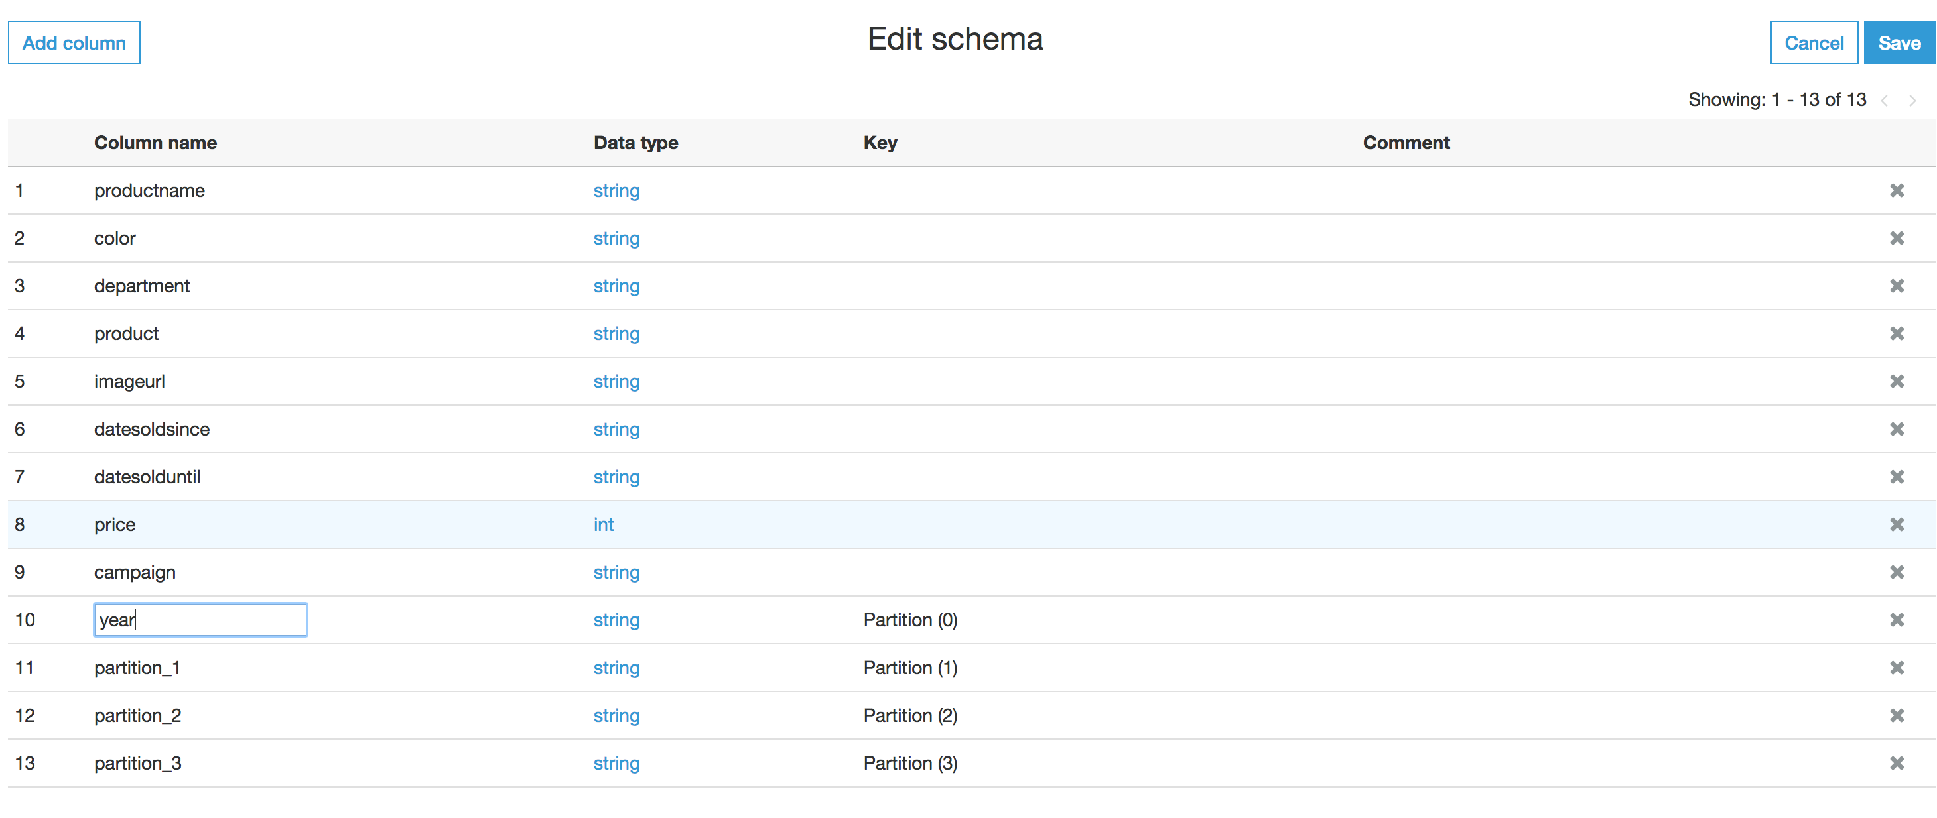

1. Note that Glue keeps track of the schema versions

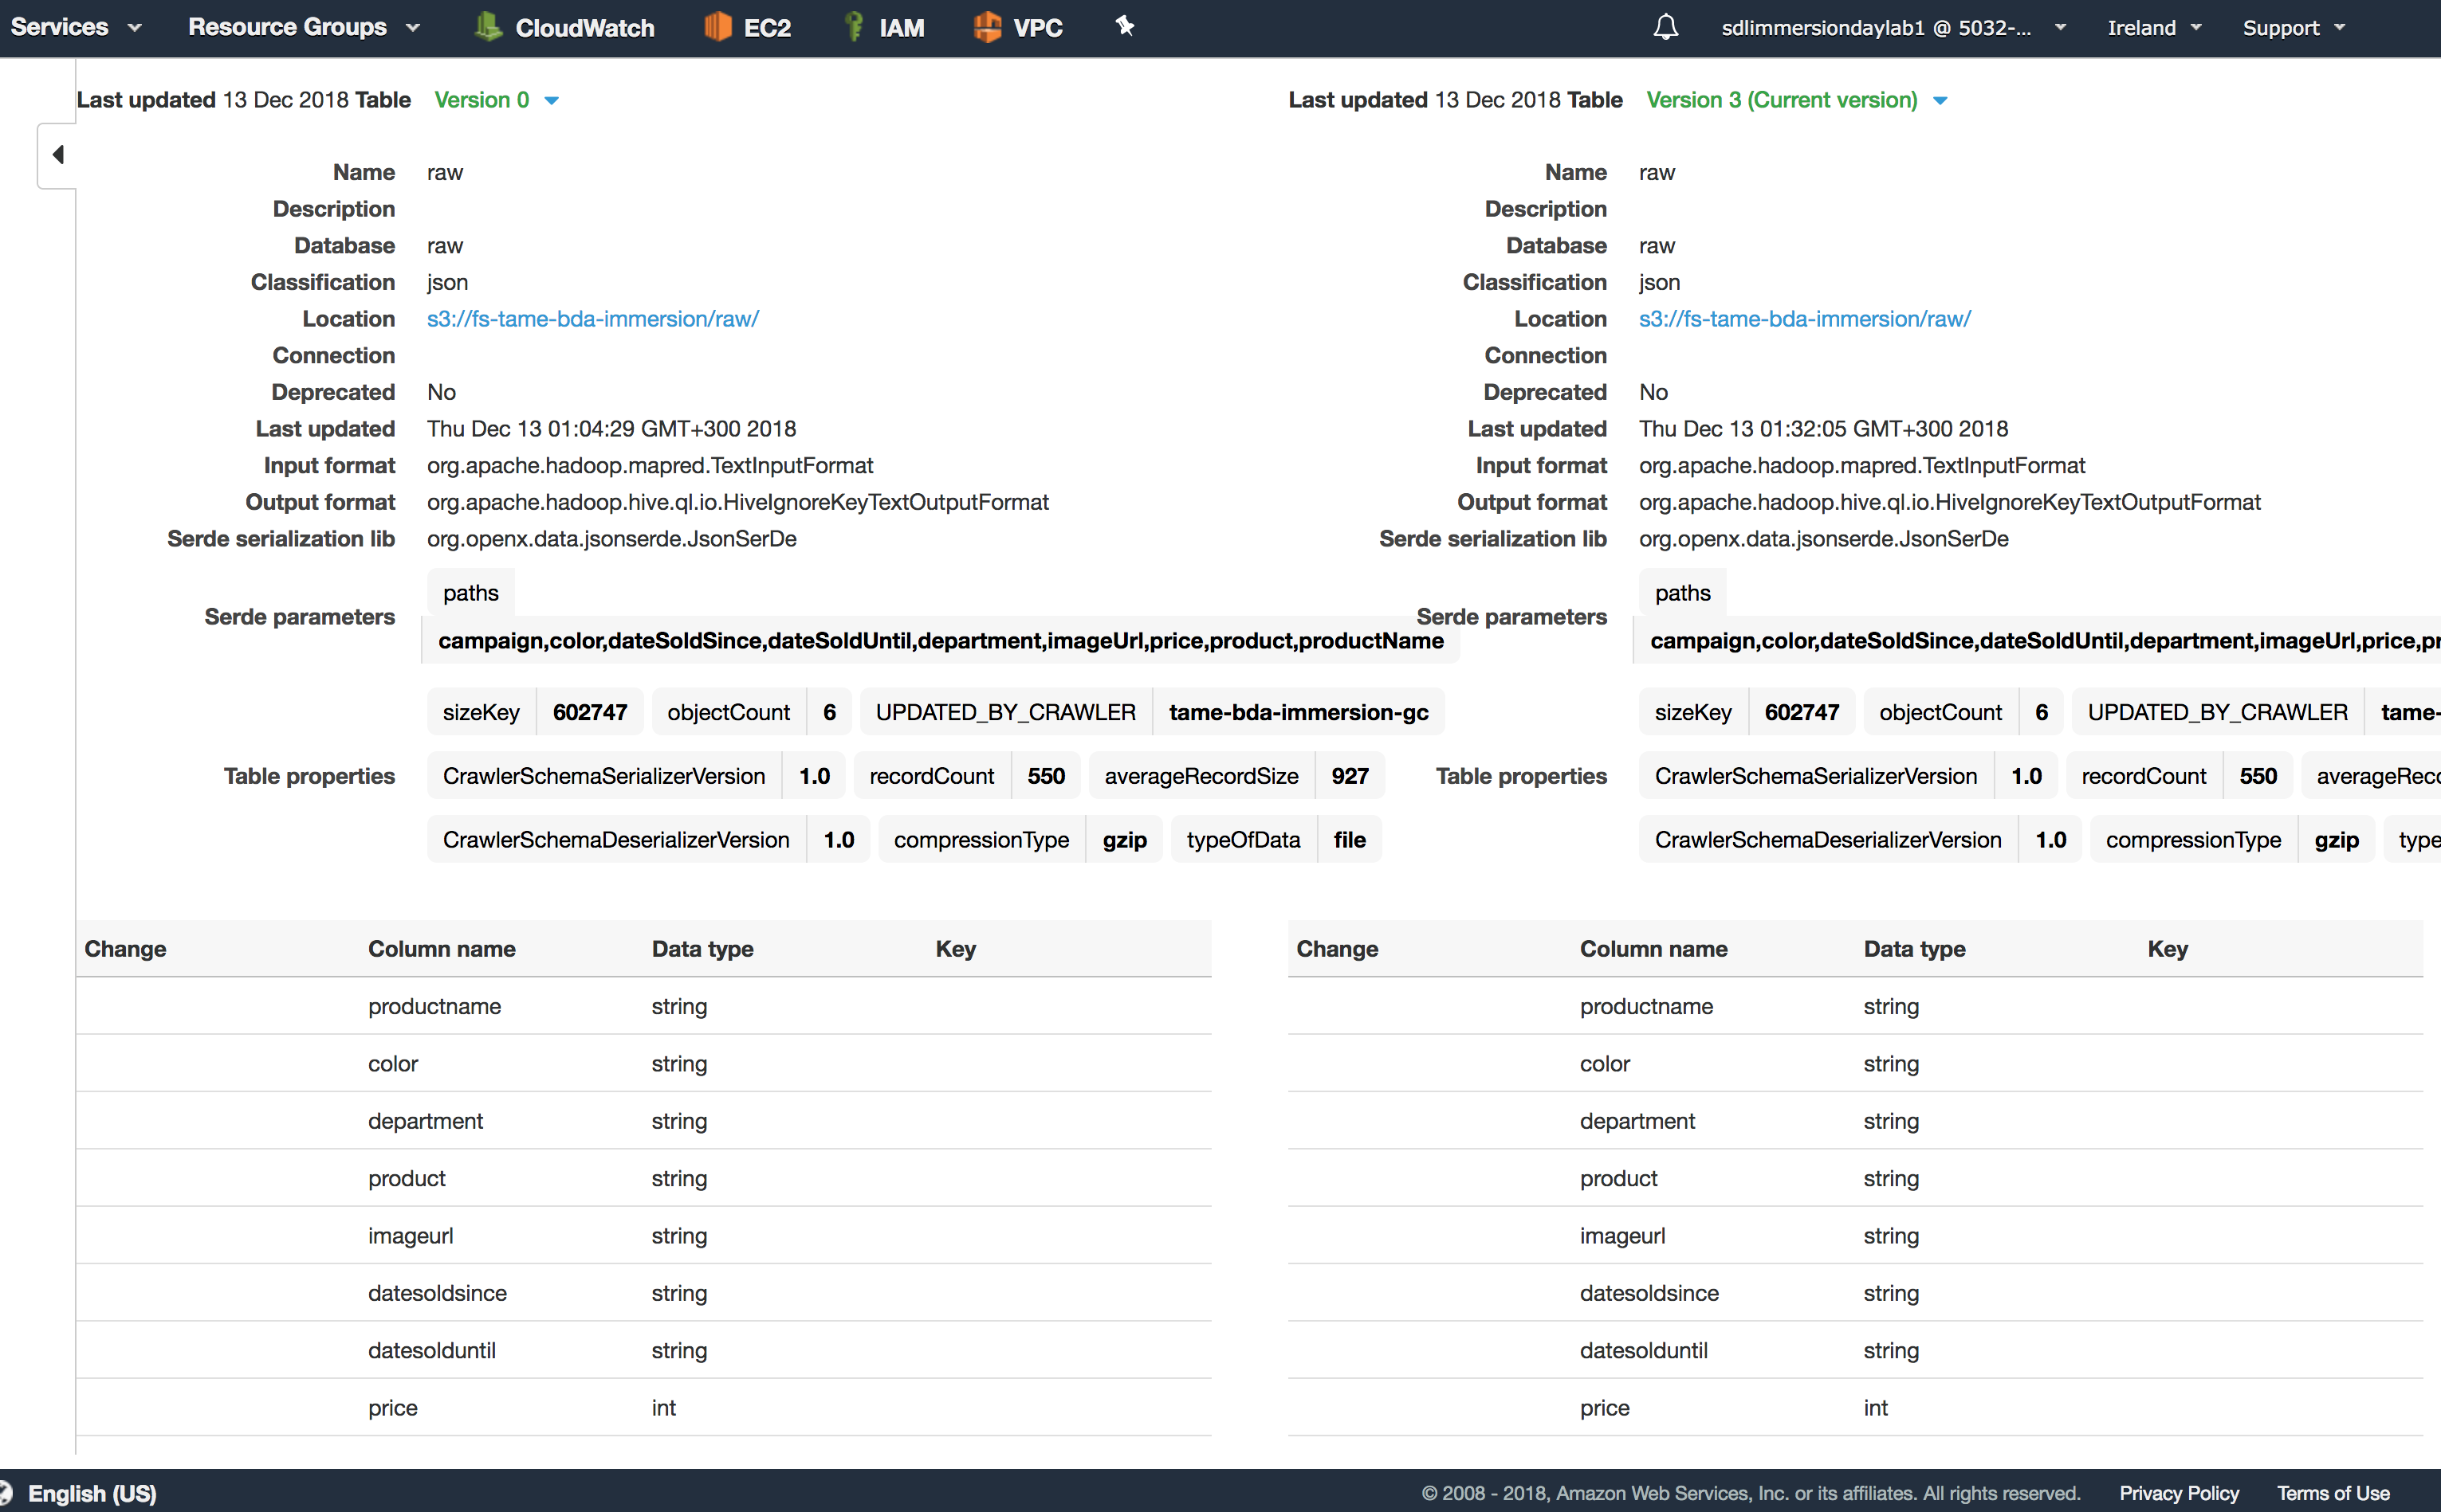

# Lab 2.2 - Transforming a Data Source with Glue

The transform pipeline is the next piece of the puzzle. It defines the necessary steps to transform partitioned raw JSON data from the AWS S3 raw data bucket to partitioned [parquet](https://parquet.apache.org/) data in the AWS S3 processed data bucket.

In this lab, you will create a job to perform basic tranformation on the source data: You will

* rename two fields,
* drop one field
* convert the raw data into a compressed columnar format (Parquet) to another S3 bucket.

Glue concepts used in the lab:

* **ETL Operations**: Using the metadata in the Data Catalog, AWS Glue can autogenerate Scala or PySpark (the Python API for Apache Spark) scripts with AWS Glue extensions that you can use and modify to perform various ETL operations. For example, you can extract, clean, and transform raw data, and then store the result in a different repository, where it can be queried and analyzed. Such a script might convert a CSV file into a relational form and save it in Amazon Redshift.
* **Jobs**- The AWS Glue Jobs system provides managed infrastructure to orchestrate your ETL workflow. You can create jobs in AWS Glue that automate the scripts you use to extract, transform, and transfer data to different locations. Jobs can be scheduled and chained, or they can be triggered by events such as the arrival of new data.
  + AWS Glue runs your ETL jobs in an Apache Spark serverless environment.
  + AWS Glue can generate a script to transform your data. Or, you can provide the script in the AWS Glue console or API.
  + You can run your job on demand, or you can set it up to start when a specified trigger occurs. The trigger can be a time-based schedule or an event.
  + When your job runs, a script extracts data from your data source, transforms the data, and loads it to your data target. The script runs in an Apache Spark serverless environment in AWS Glue.

1. Let’s assume, we’d like to have a central repository of our ETL scrips fort his Project. Instead of using the default path of Glue, first create a folder under your bucket **“<your-initials>-tame-bda-immersion”** called **“scripts-etl”**
   * Open S3 service in a separate tab (don’t close the current Glue tab, we’ll need to continue
   * G oto bucket **“<your-initials>-tame-bda-immersion”**
   * Create a folder called  **“scripts-etl”** underneath.

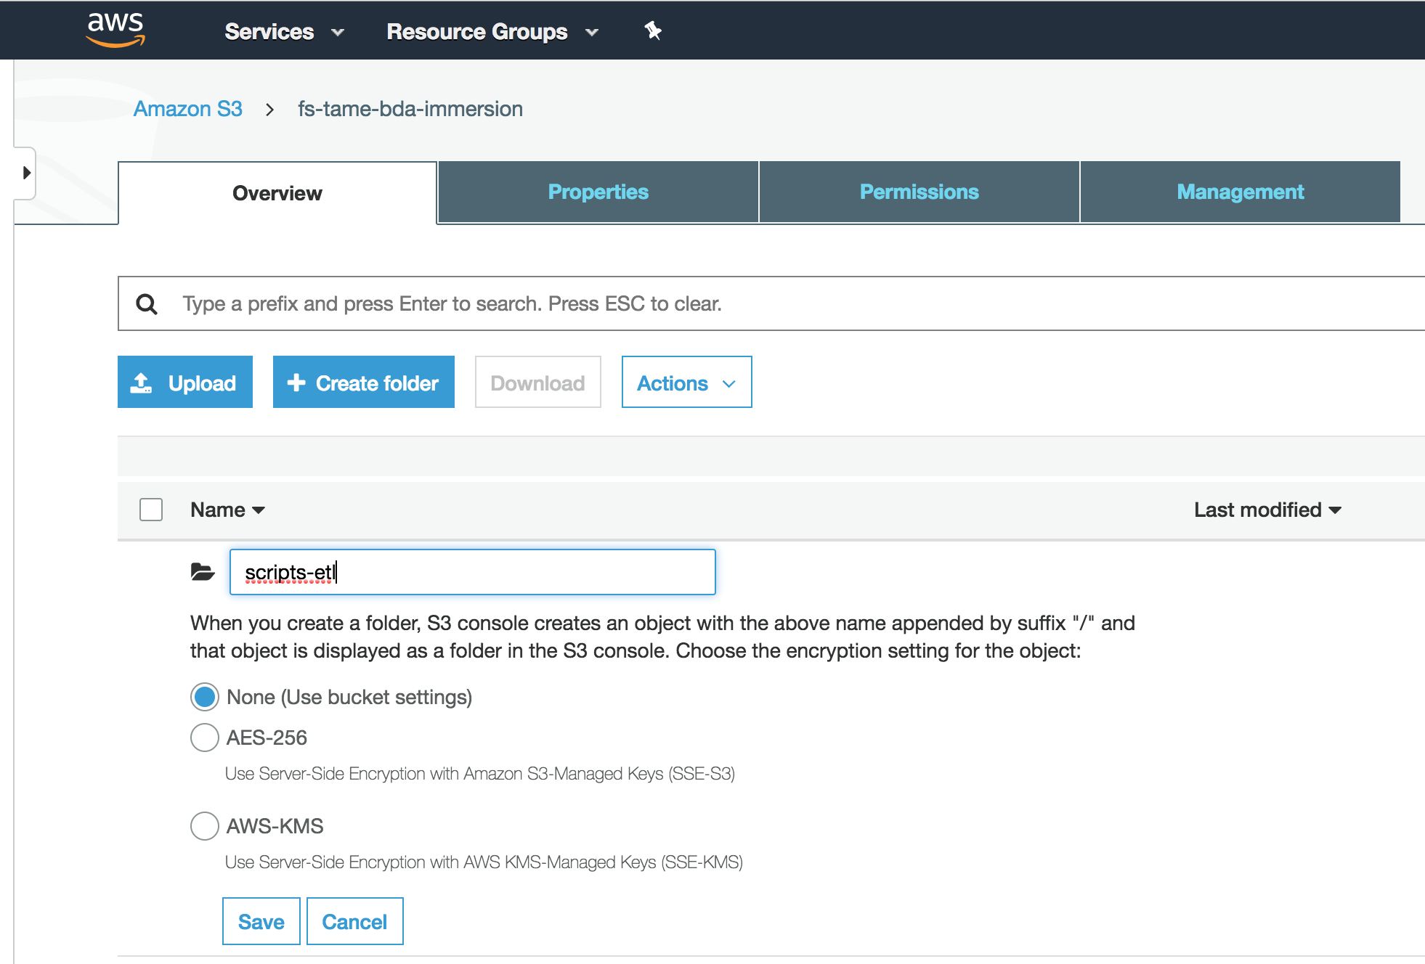

1. G oto Glue console and Create a glue job with the configuration below by selecting **Glue -> ETL -> Jobs “Add Job”.** Enter job details like below:
   * Job Properties Stage:
   * Job name: **gj-tame-bda-kdg-raw2parquet**
   * IAM Role:
     + Choose IAM role: select **Choose** **existing IAM role.** The Cloudformation Template created an IAM role with a name like **sdlimmersion-tameGlueRoleSlessDataLakeImmersion-<UNIQUE ID>**
   * This job runs:
     + Select “A proposed script generated by AWS Glue”
   * ETL Language:
     + Select “Python”
   * Script name:
     + Enter: **gj-tame-bda-kdg-raw2parquet**
   * S3 path for script:
     + **Enter <your-initials>-tame-bda-immersion/scripts-etl**
   * S3 path for temp files: Do not change. **<glue provides a default value>**
   * Open Advanced Properties section:
     + job bookmarks: Choose **enable**
     + job metrics: Choose **enable**

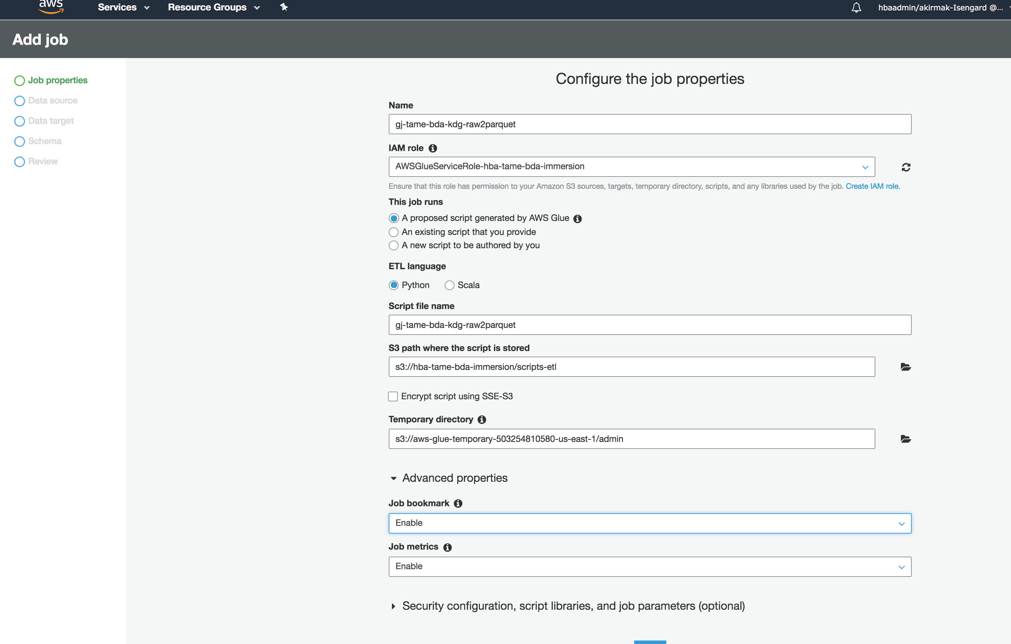

1. Data source Stage: Select the **raw** table from our Glue DB

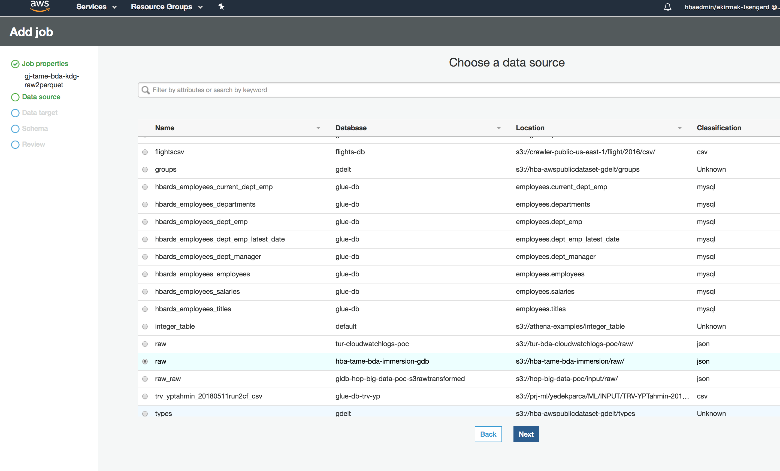

1. Data Target Stage: Select output DS as S3, and type as Parquet. Enter **s3://<your-initials>-tame-bda-immersion/compressed-parquet**

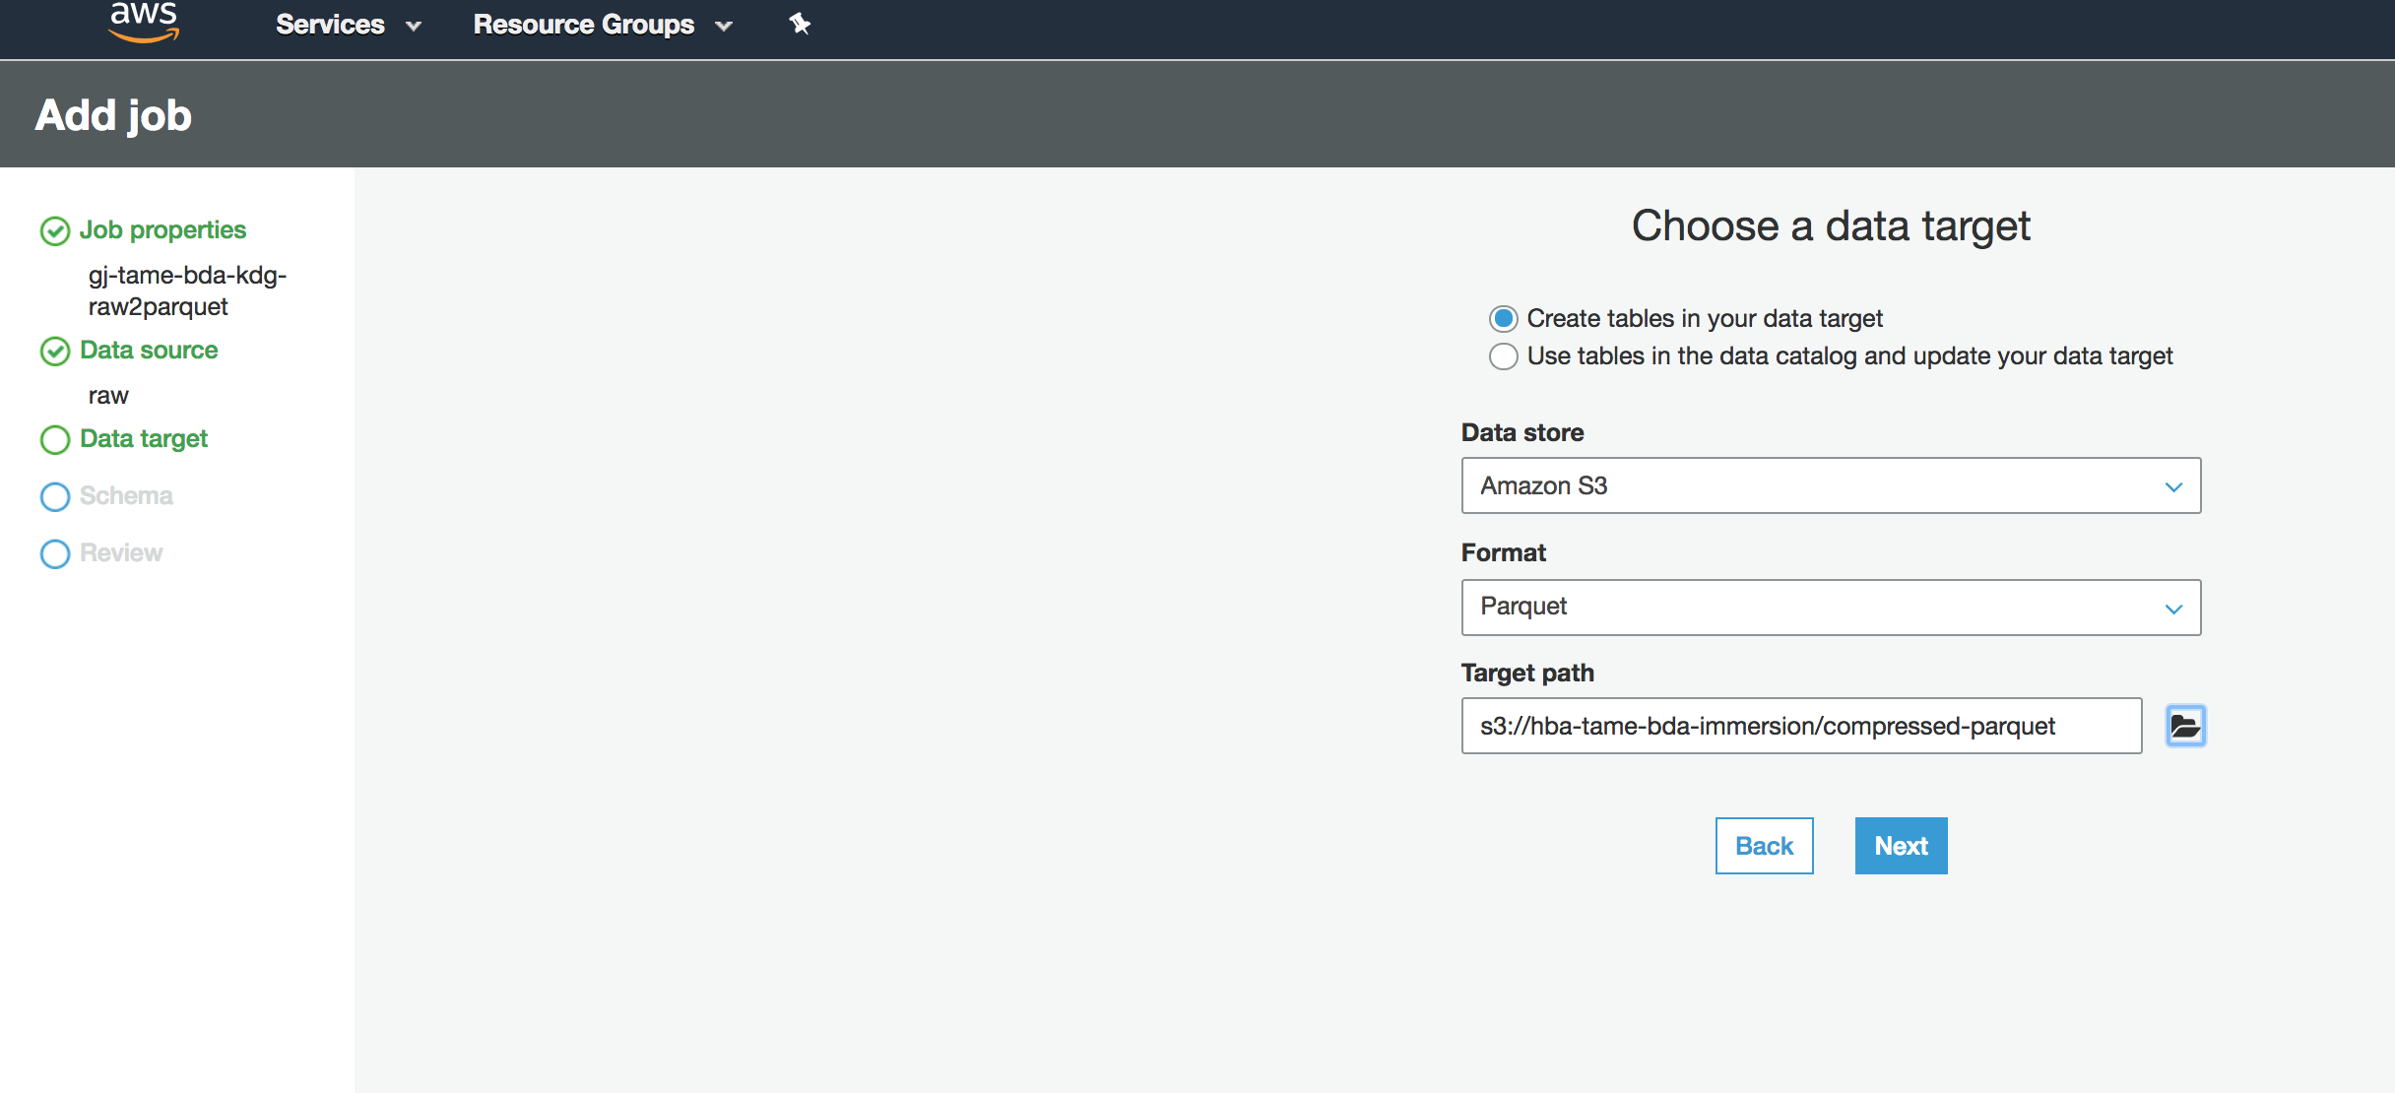

1. Schema Stage:
   * Create a field mapping as follows from the GUI:
     + Remove **color** from target.
     + Rename **datesoldsince** to **date_start**
     + Rename **datesolduntil** to **date_until**

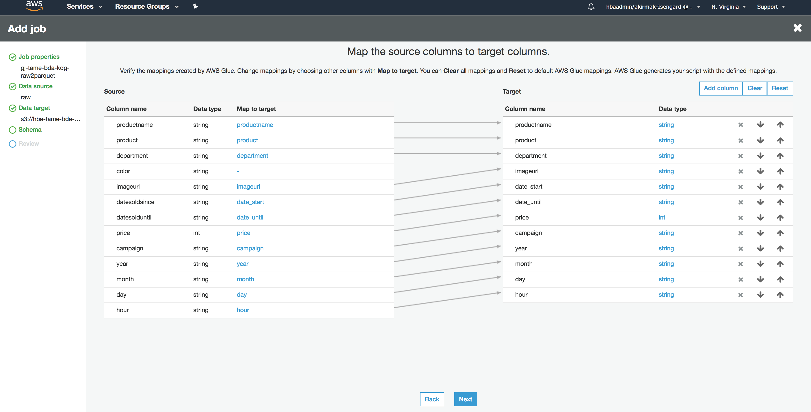

1. Review Stage:
   * Have a look at the generated script:

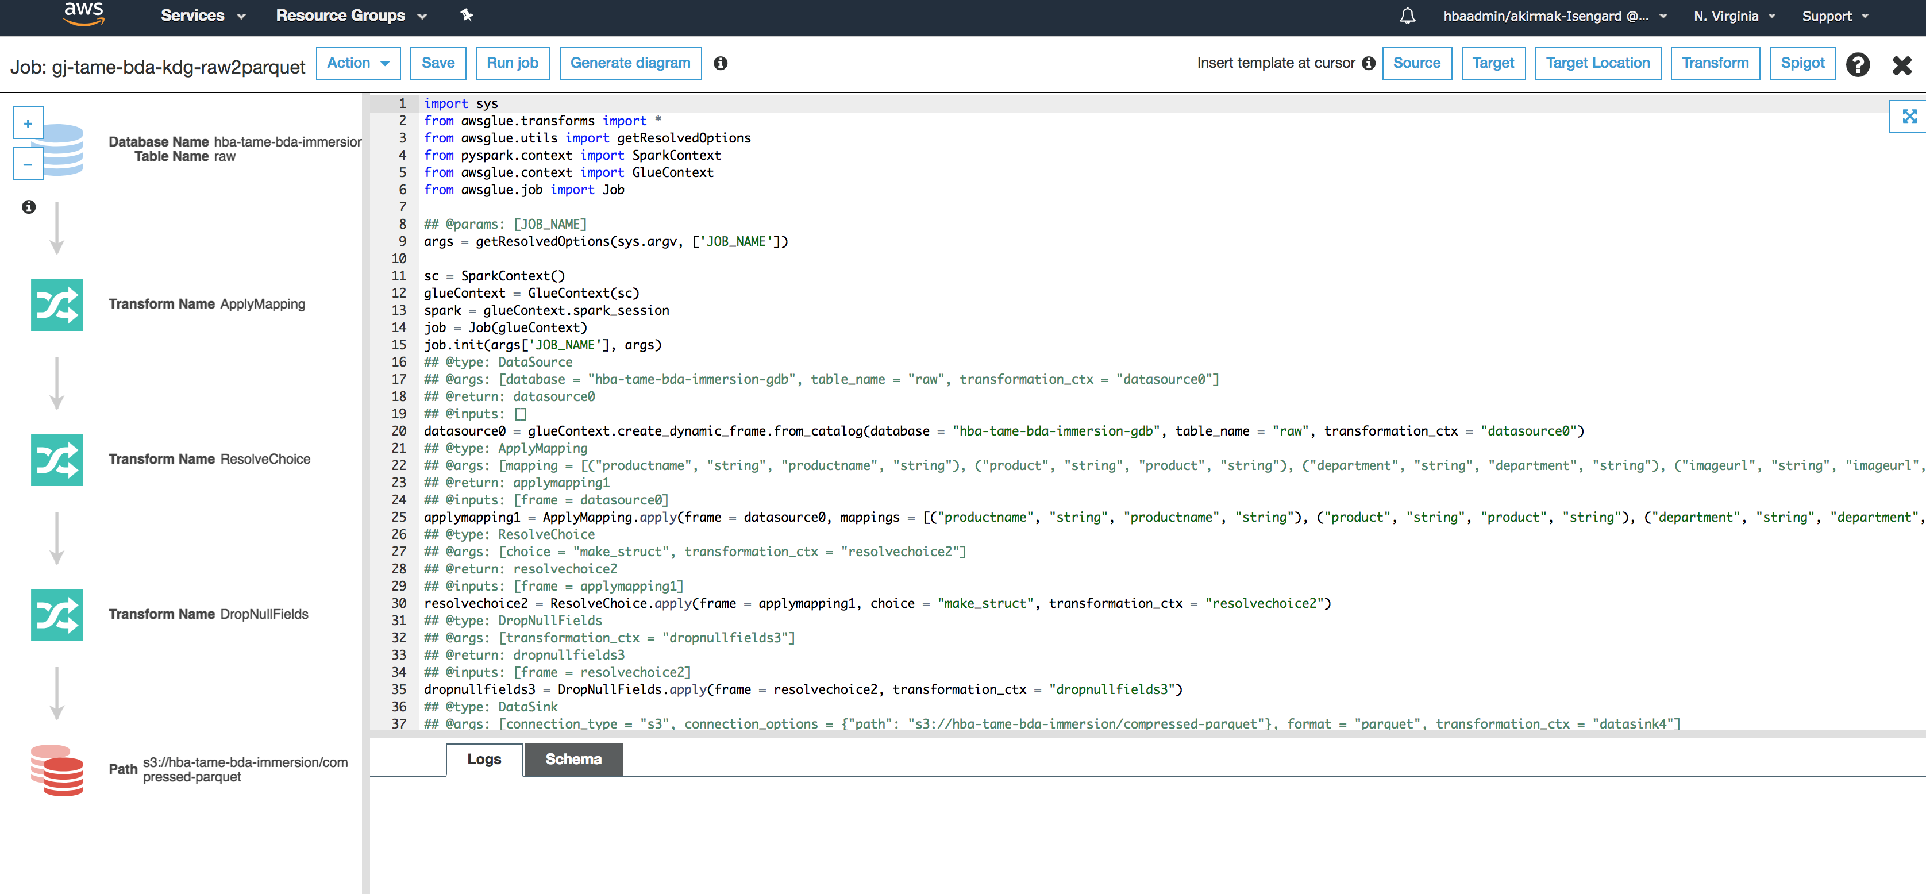

**Notice:** This image (from another Project) provides a graphical explanation of the several sections in the code. If you don’t have previous experience with PySpark, Data Frames or Python development, don’t worry. You won’t be making any coding here. The code simply implements the field mapping transformations you specified in the GUI (a field is dropped out, other fields have been renamed etc.). The data engineering team will likely write code for transformations in your data source. Simple transformations can be done from the GUI.

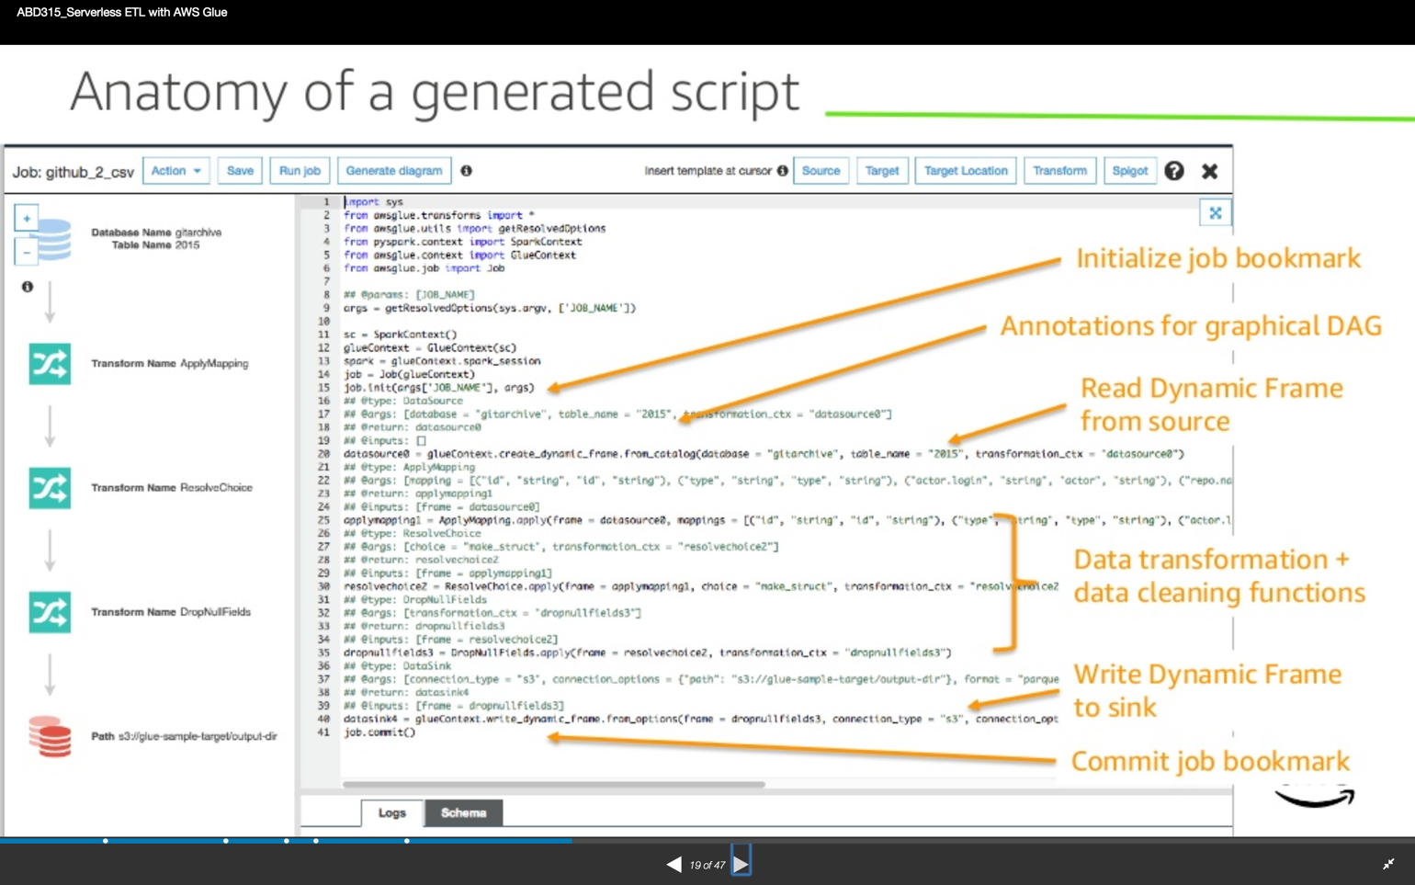

1. Save the script and close the edit script window.
2. In the Glue ETL -> Jobs screen below
   * select the job you created (**<your initials> -gj-tame-bda-kdg-raw2parquet)**
   * Select **“Actions”** from the menü
   * Select “**Run”** the job when you are finished

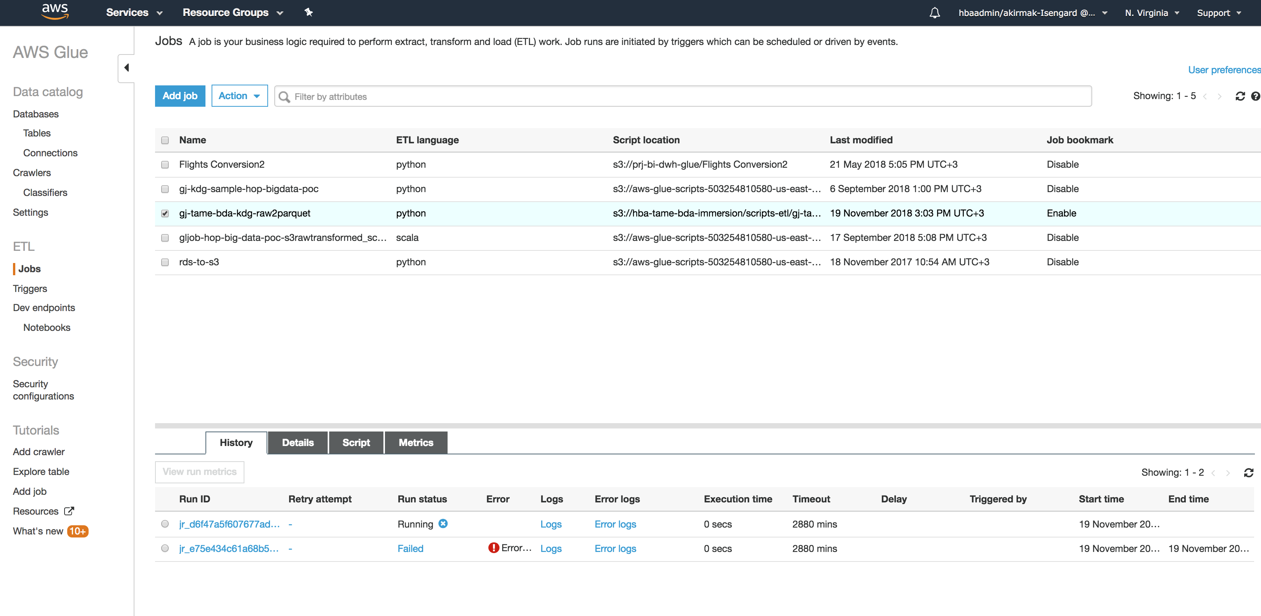

1. Wait a few minutes while the job is going through stages.
   * “Starting”,
   * “Running and
   * “Stopped”
2. When the job is finished, verify the transformed files are in the output folder
   * you should see files with “parquet” extension.
   * In our case, the Raw folder was already stored as gzip, so the compresion provided by parquet will not be huge.

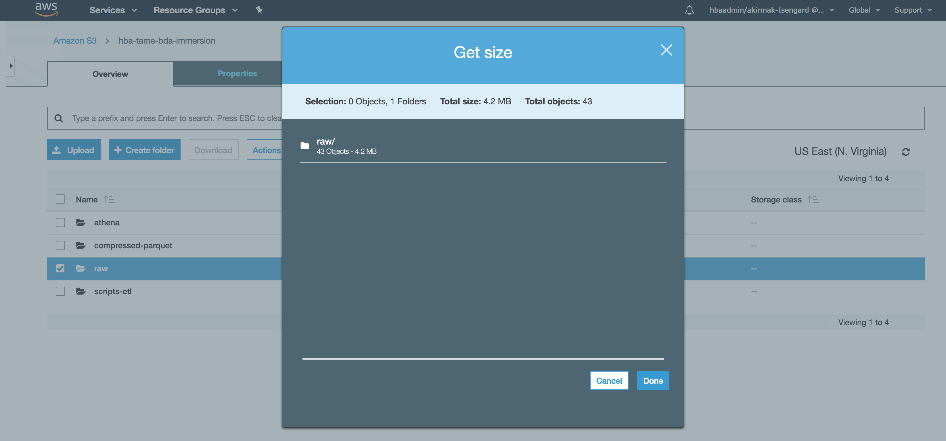

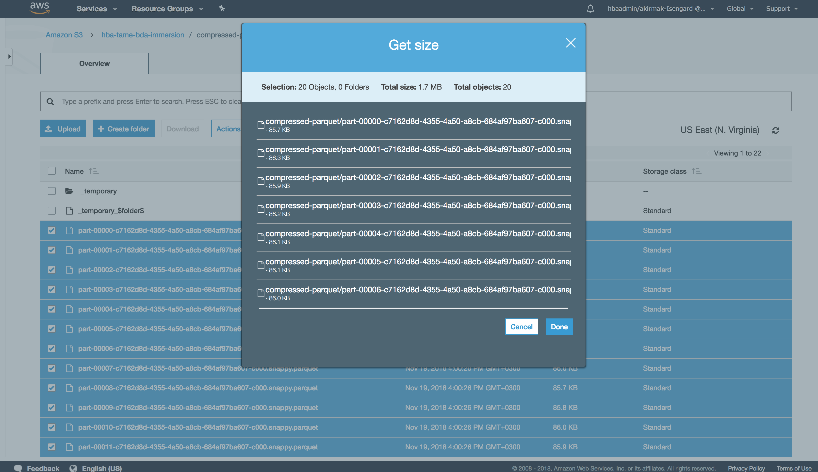

1. Check glue runtime performance metrics by selecting ‘detailed job metrics’:
   * The Metrics tab can be seen when you select the job as follows:



* + Here’s how the metrics would look like. Since the job and the dataset is too small, there’s not much load on the service.

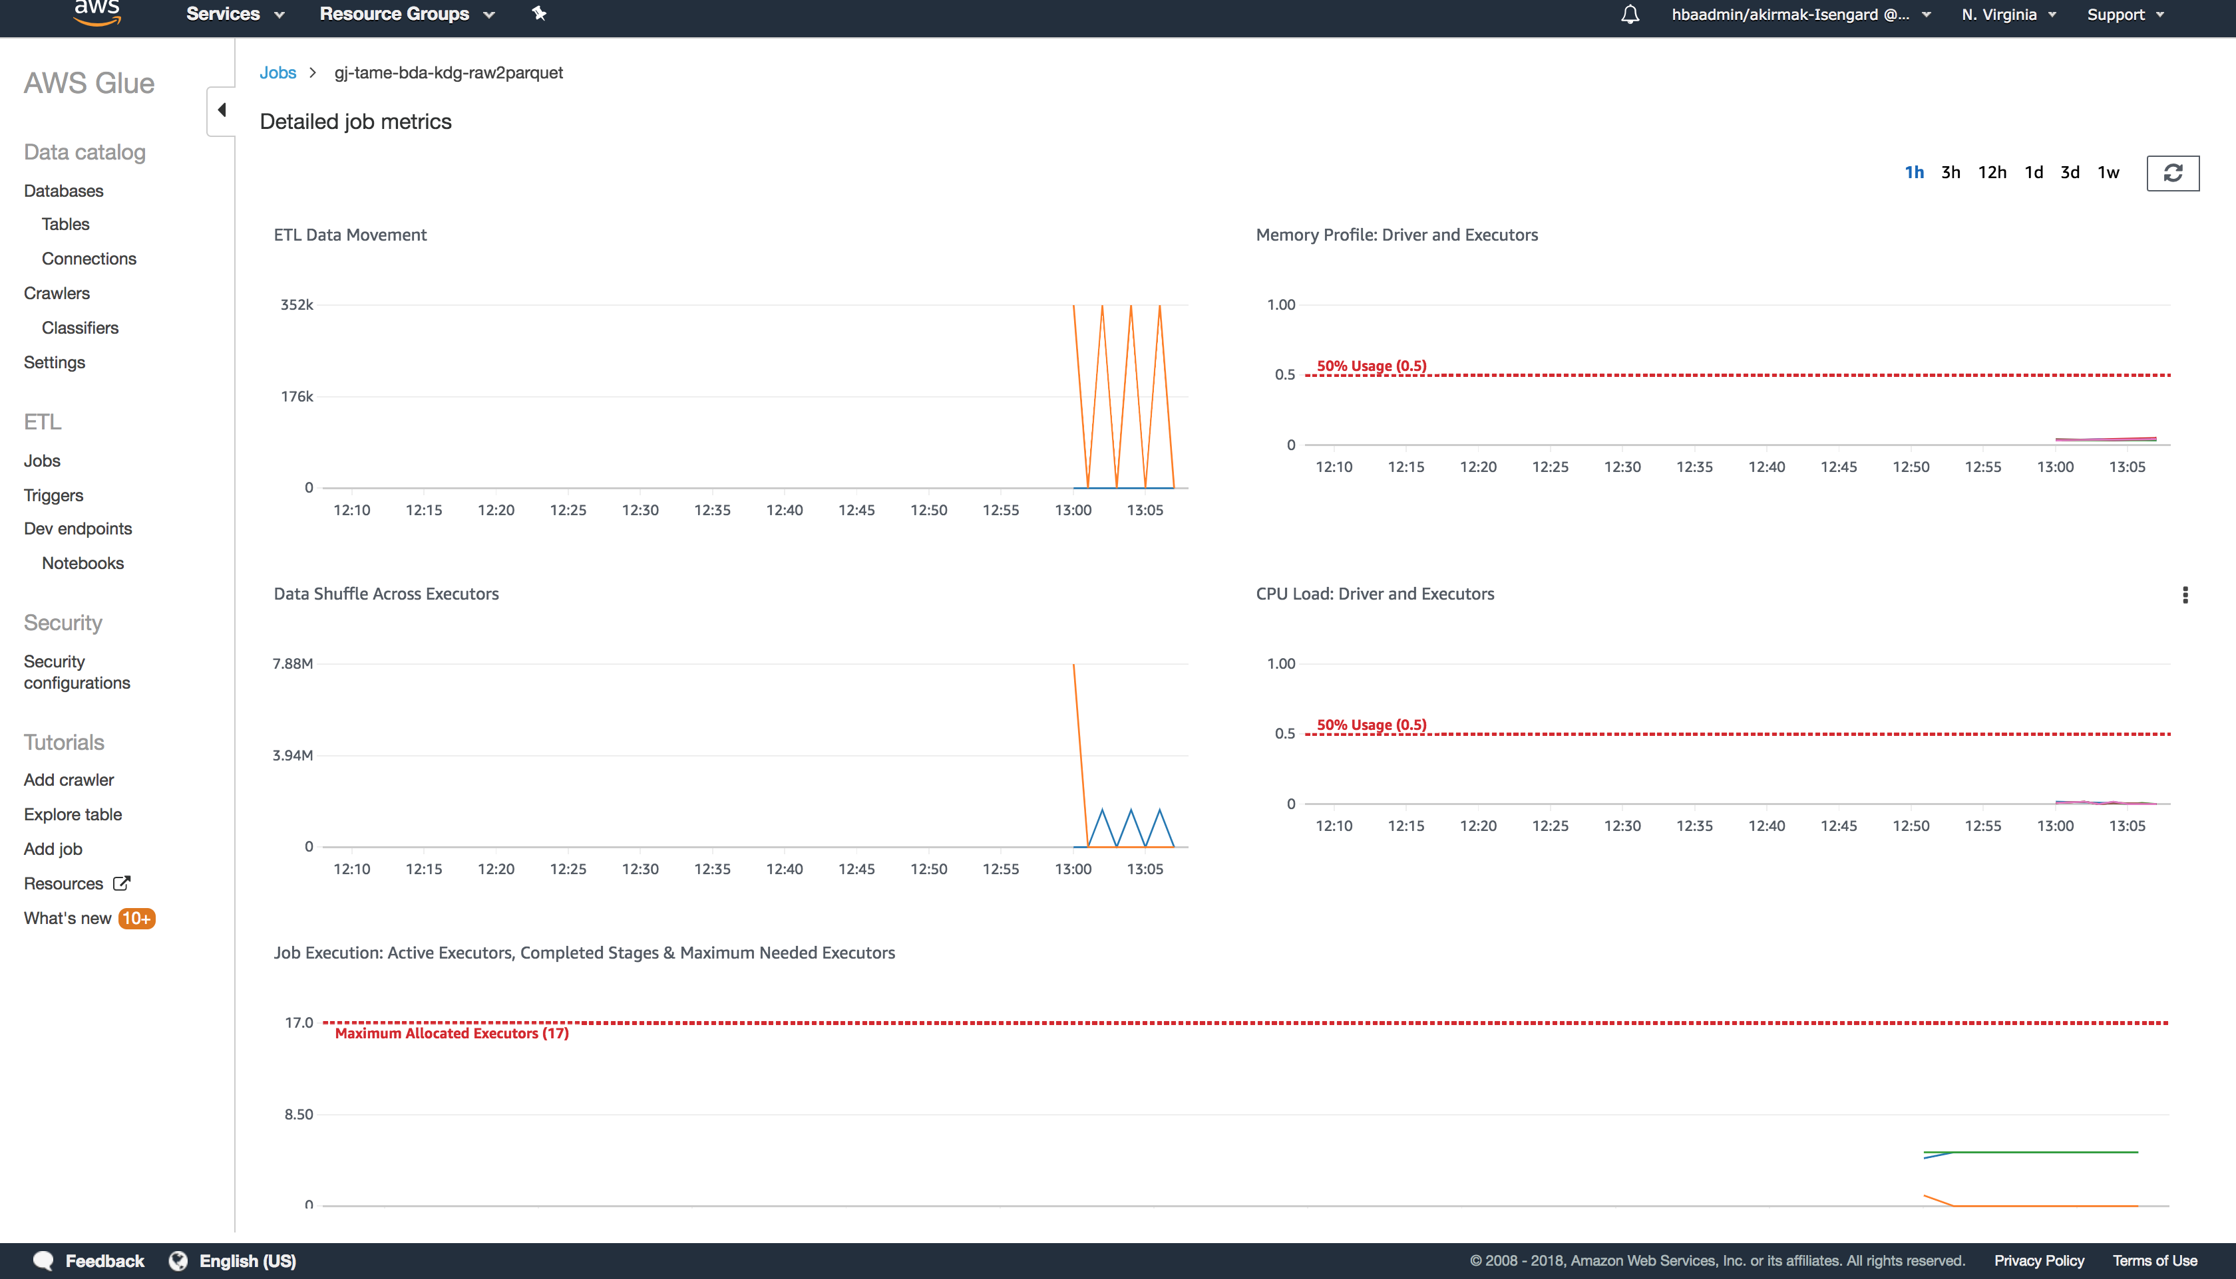

# Lab 2.3 - Advanced Data Preparation with Glue Developer Endpoints and Notebook

An ETL job with basic transformations can be created from Glue Console as explained in the previous Lab. Often, the data sources, the data formats and transformation requirements are diverse and complex. In that case, a REPL (read-eval-print-loop) approach, where an interactive programming environment such as a Jypiter Notebook running PySpark or Scala is needed for data preparation.

Data Engineers will find the Developer Endpoint feature for AWS Glue very useful. They can spin up an endpoint when they are ready to build a pipeline. After trying some data manipulations in a REPL fashion, one can have Glue build an EC2 instance to host Jupyter and build a PySpark script to be saved in S3. When they are done, they just tear it all down; the best part is that if they want to go back and modify the script, they can create a new notebook and even collaborate with other Data Engineers on the same pipelines. It’s almost a source code management system for data scripting.

In this lab, you will create a developer endpoint to connect to the Glue service, and do some iterative development.

**Note:** This section is relevant for data engineers & software developers.

## Lab 2.3.1 Create a Developer Endpoint:

A development endpoint is an environment used to develop and test your AWS Glue scripts. This is useful if you need to do advanced data preparation on your data in the data lake that is beyond the rename field, add/drop field type of transformations you have done in the previous lab.

1. Create a Glue Development Endpoint with the configuration below:
   1. **Properties**:
      * Endpoint-name: e.g. **gj-tame-bda-kdg-raw2parquett-devEndpoint**
      * IAM Role: Select the role created by the CloudFormation template. (the Name should be like: sdlimmersion-tameGlueDevEndpRoleSlessDataLake-<UNIQ ID> . **Note:** This role provides permissions similar to the AWS managed policy called AWSGlueServiceRole, plus access to your data stores such as: **s3://<your initials>-tame-bda-immersion/raw**
      * DPU’s: 5

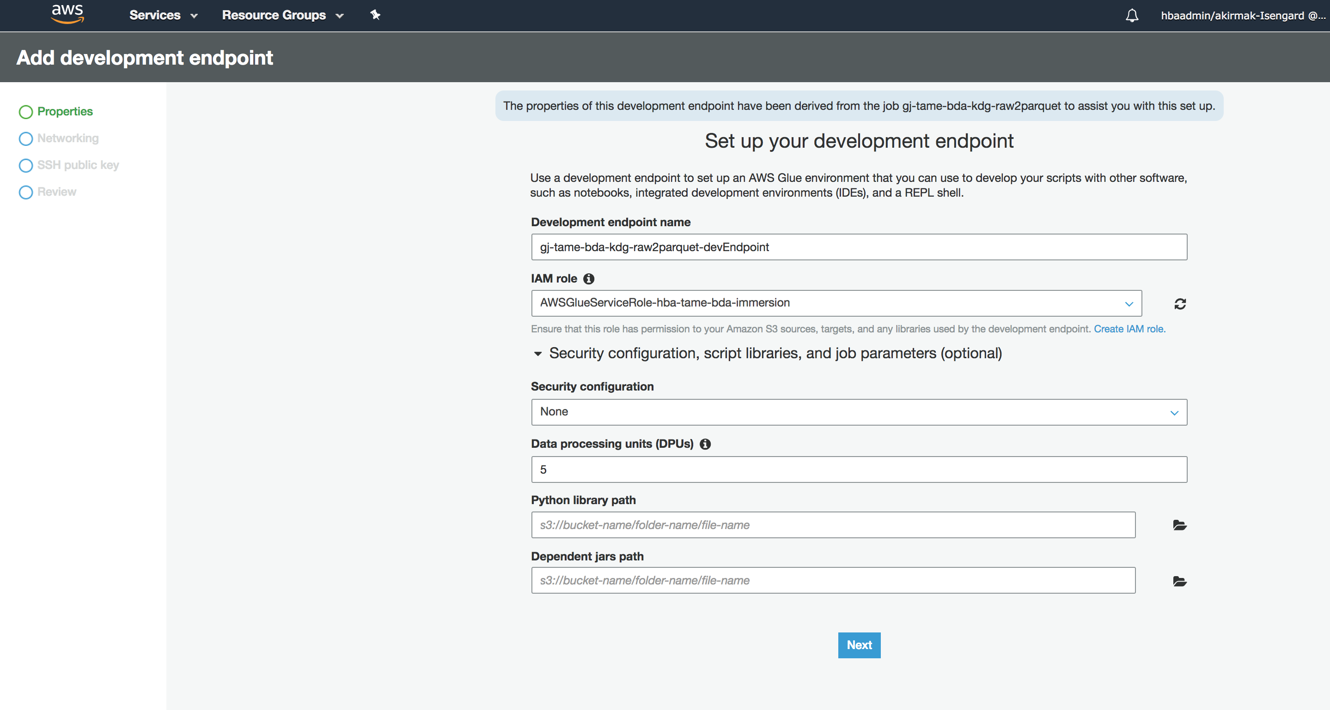

* 1. **Networking**: Select Skip networking information (We selected this option, because we will be only connecting to S3 from the notebook).

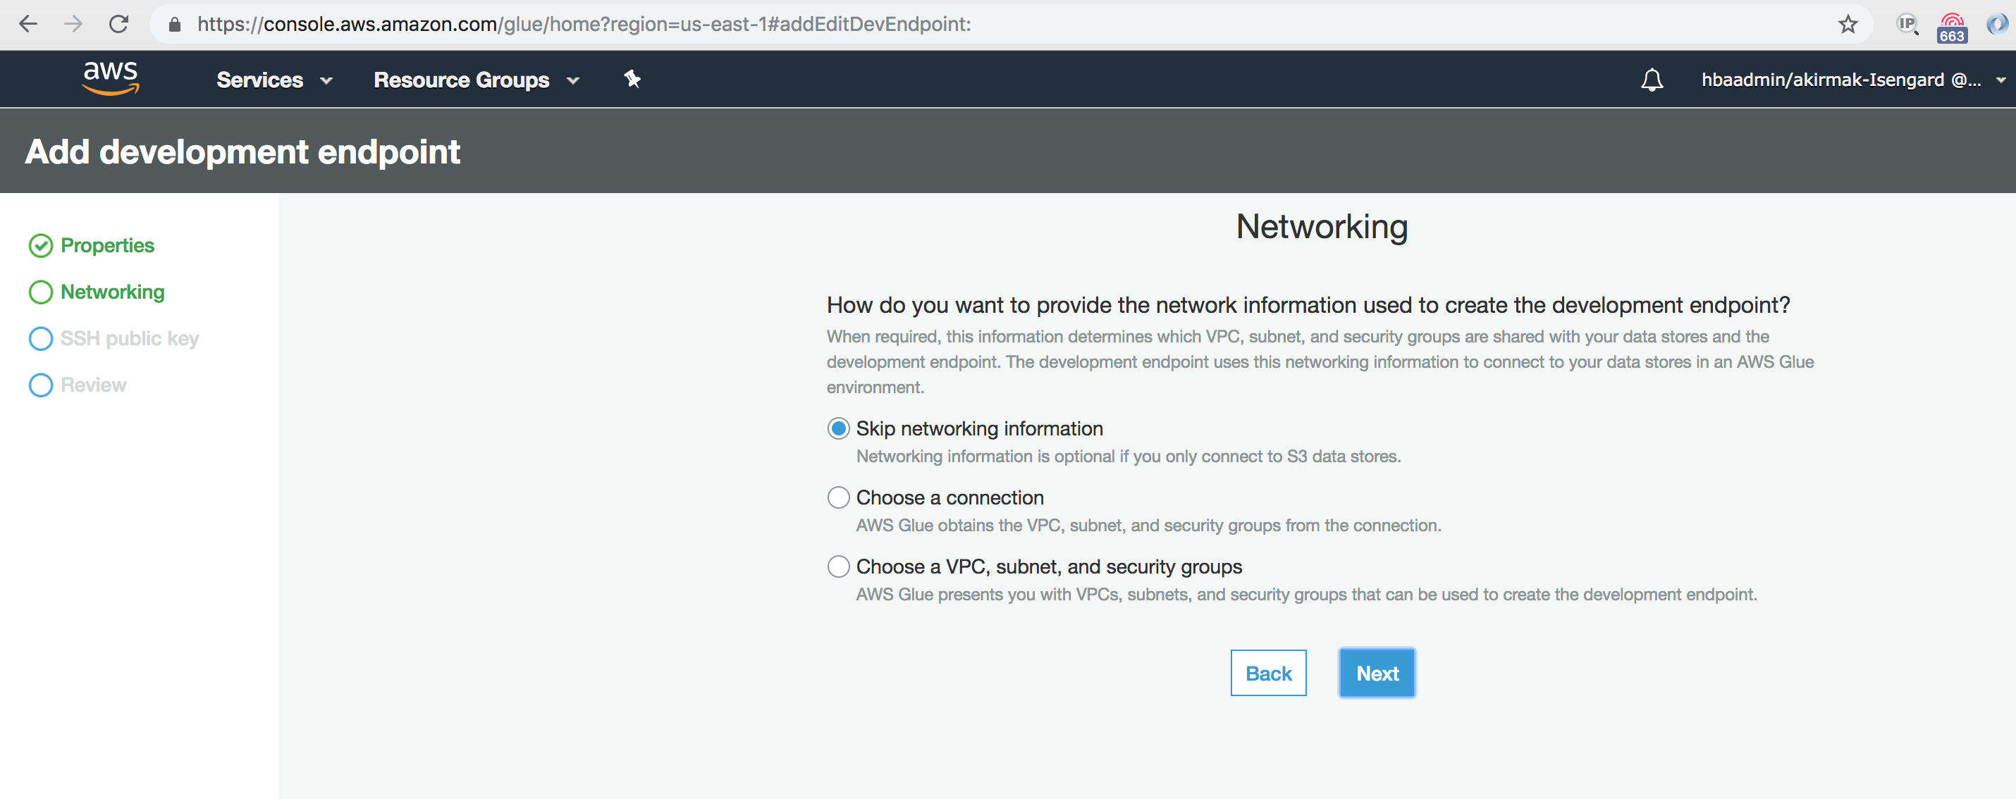

* 1. **SSH Public Key**: Skip this step, since you will be using Sagemaker notebook to communicate with the Dev Endpoint.

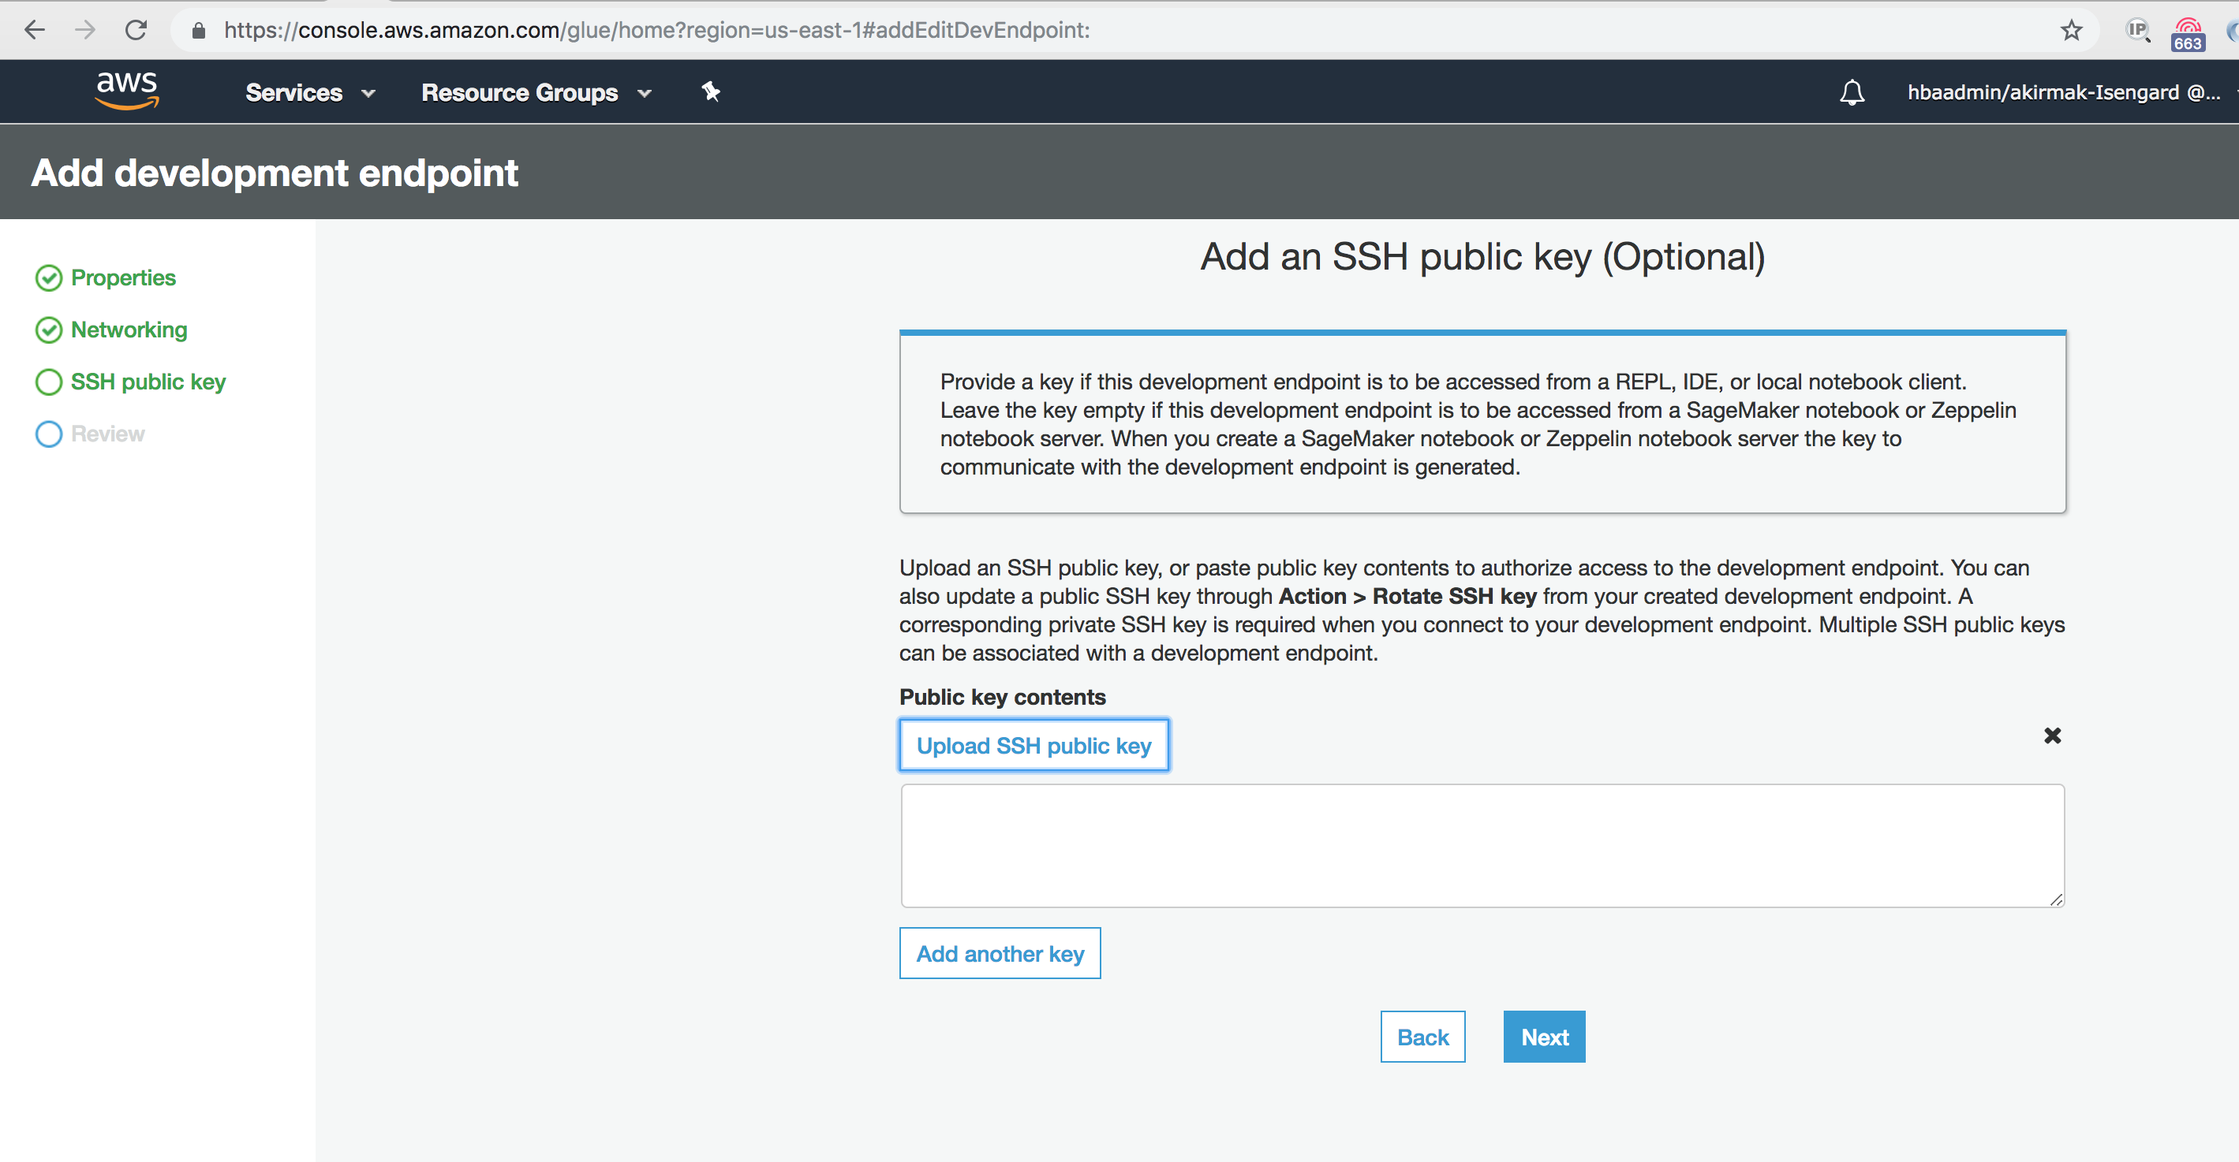

* 1. **Review:** Select review and press Finish. At this stage, what we created is a gate to the underlying Glue service cluster. You will now create a notebook instance.
  2. When ready, choose the development endpoint and create a notebook to test your scripts. You can either choose **Action**, **Create SageMaker notebook or Action, Create Zeppelin notebook server.** You will create a Jupyter notebook in the next section.

Here are some resources for Glue Developer Endpoints:

<https://docs.aws.amazon.com/glue/latest/dg/dev-endpoint-tutorial-prerequisites.html>

<https://docs.aws.amazon.com/glue/latest/dg/dev-endpoint-notebook-server-considerations.html>

## Lab 2.3.2 Create a Jupyter Notebook for Interactive Advanced Data Manipulations

A notebook enables interactive development and testing of your ETL scripts on a development endpoint.

1. Now, create a Sagemaker Notebook and connect to Glue Developer Endpoint
   1. Select Sagemaker notebooks -> Create Notebook

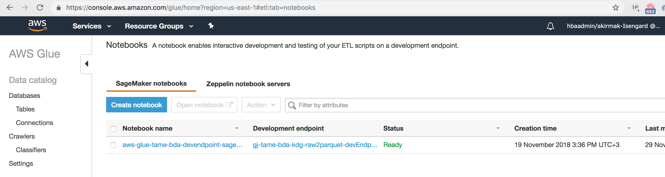

* 1. Enter following details:
     + Notebook name: **tame-bda-devendpoint-sagemaker-notebook**
     + Attach to dev endpoint: Select the DevEndpoint you’ve created from the list: **gj-tame-bda-kdg-raw2parquett-devEndpoint**
     + Select “**Choose an existing IAM role**: Choose the IAM Role created by the Cloudformation template (Name is like: sdlimmersion-tameSageMakerNBookRoleSlessDataLake-<UNIQ ID>)
     + Leave VPC and Encryption fields empty.

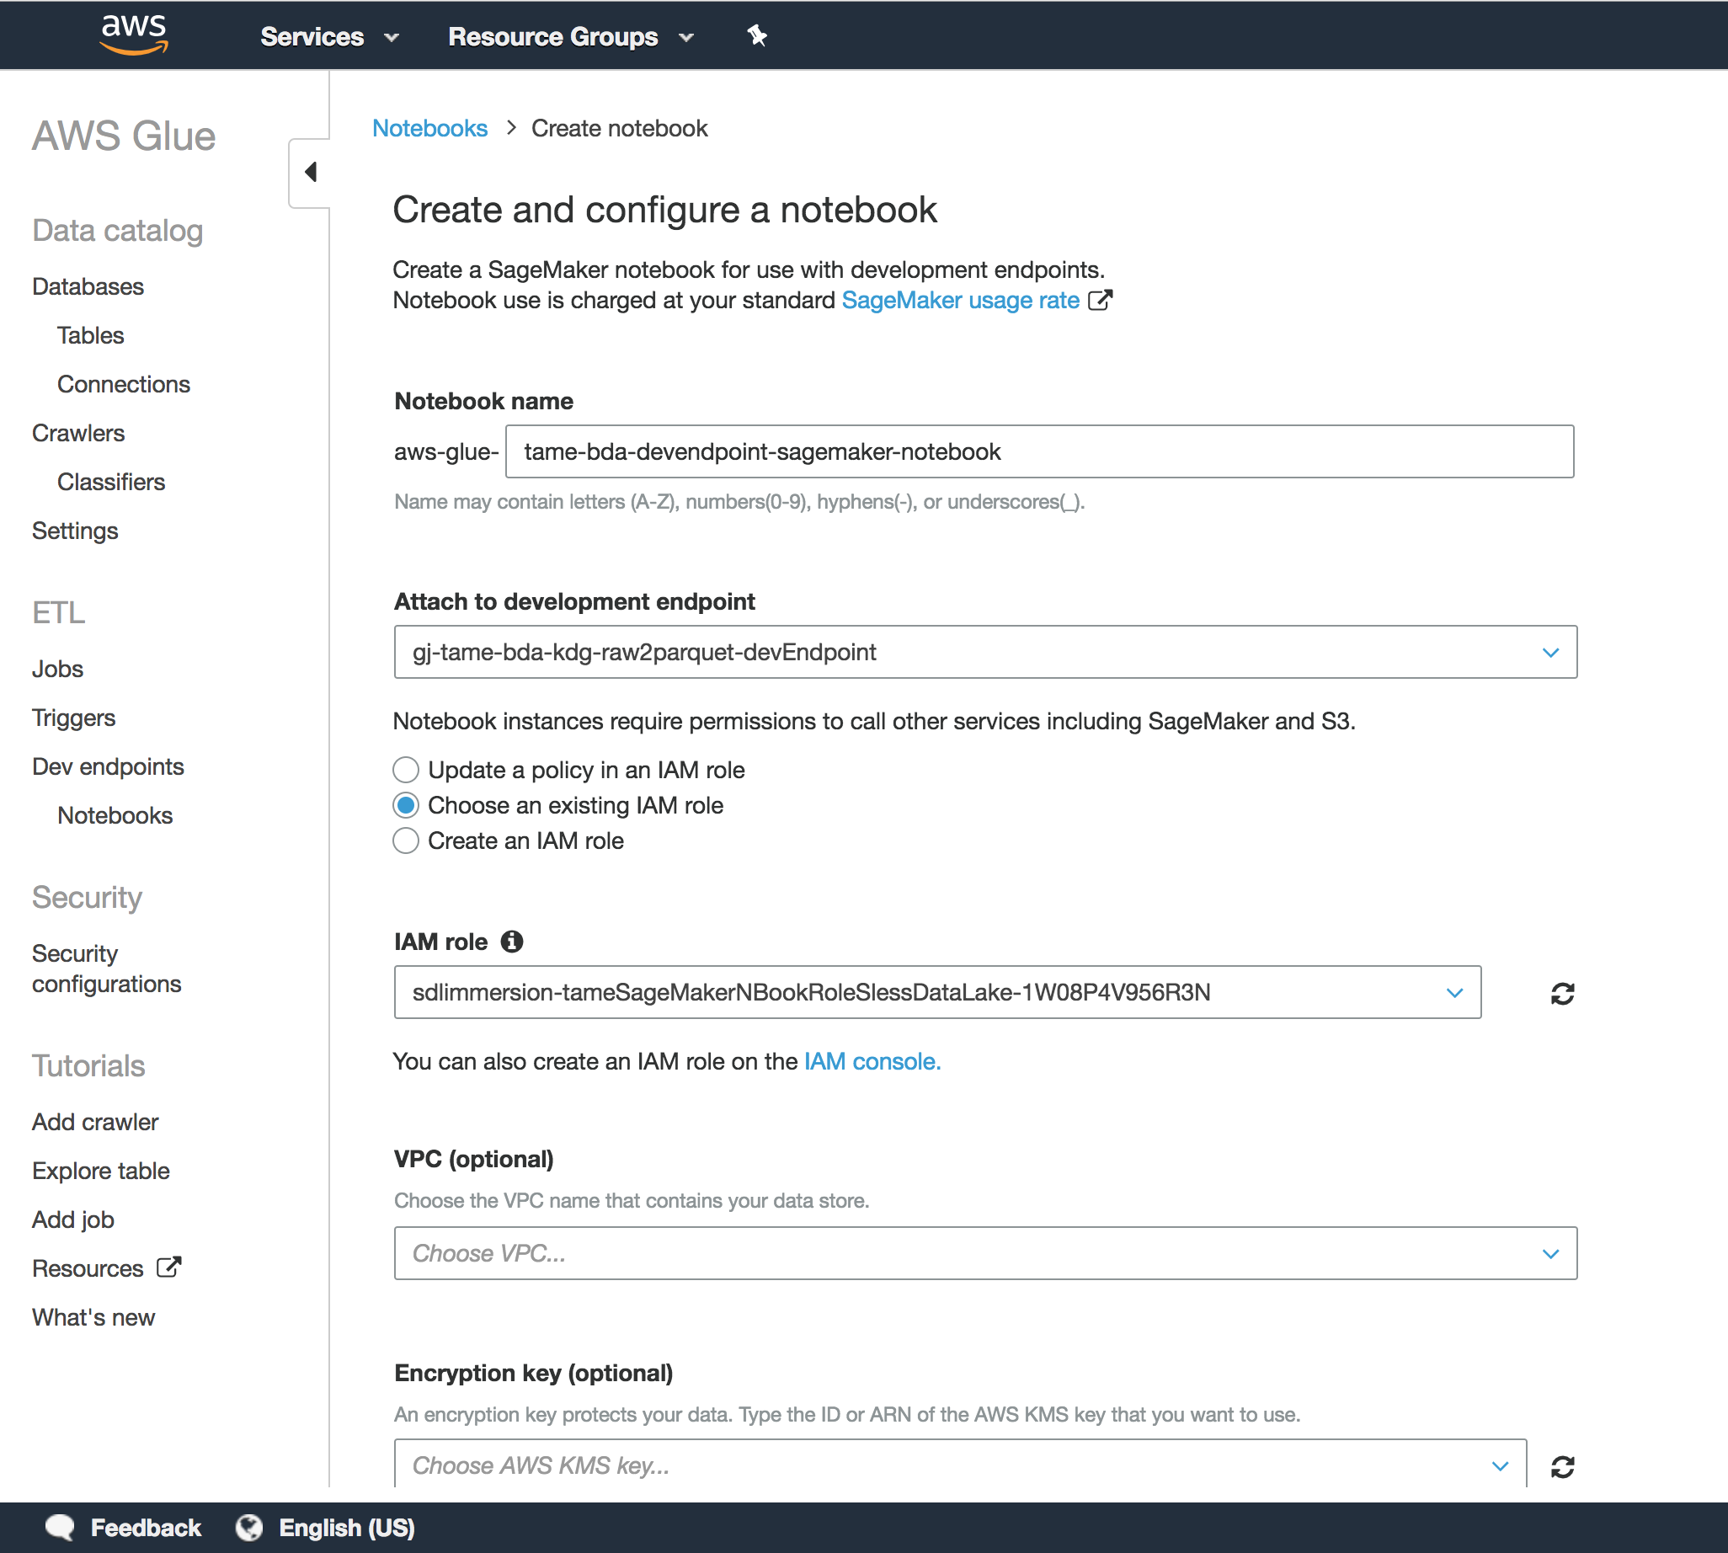

1. Open the SageMaker Notebook.

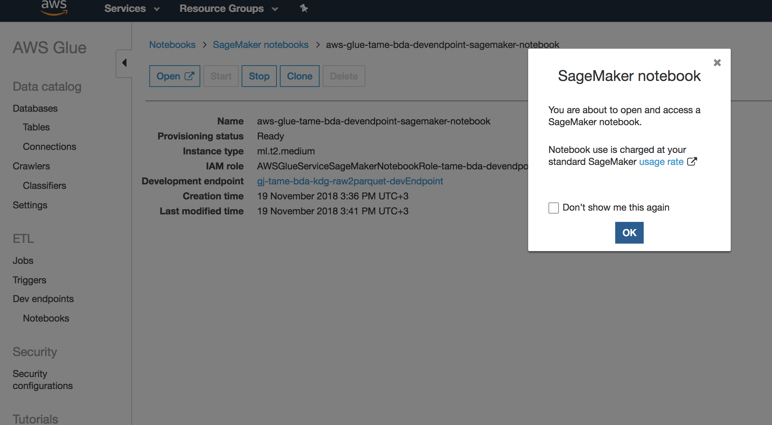

1. You will be taken to the SageMaker notebook’s Jupyter web interface.

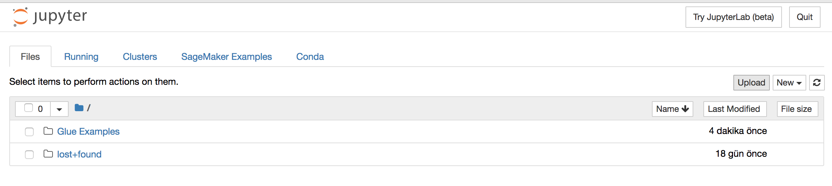

1. Press “Upload” button and upload the (iPython Notebook) file: Lab 2.3 - Advanced Data Preparation with Developer Endpoints and Notebook.ipynb to the notebook.

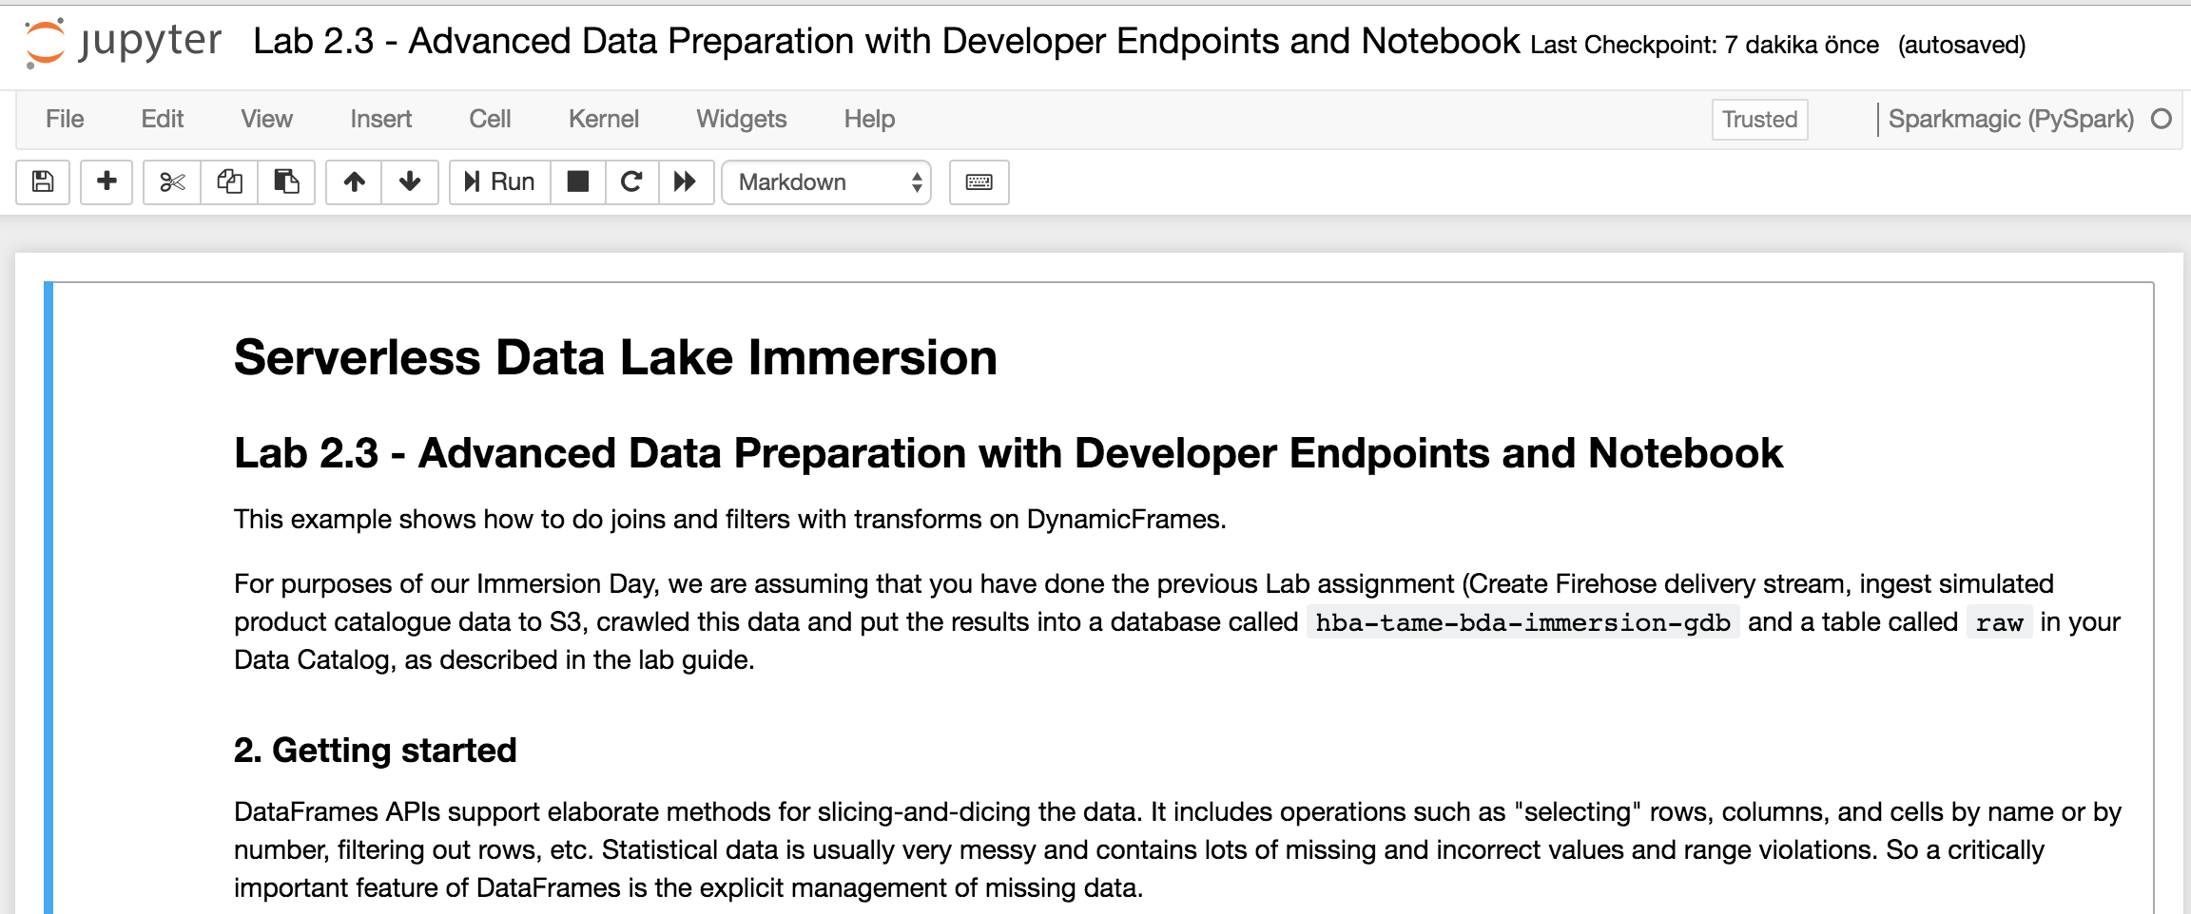

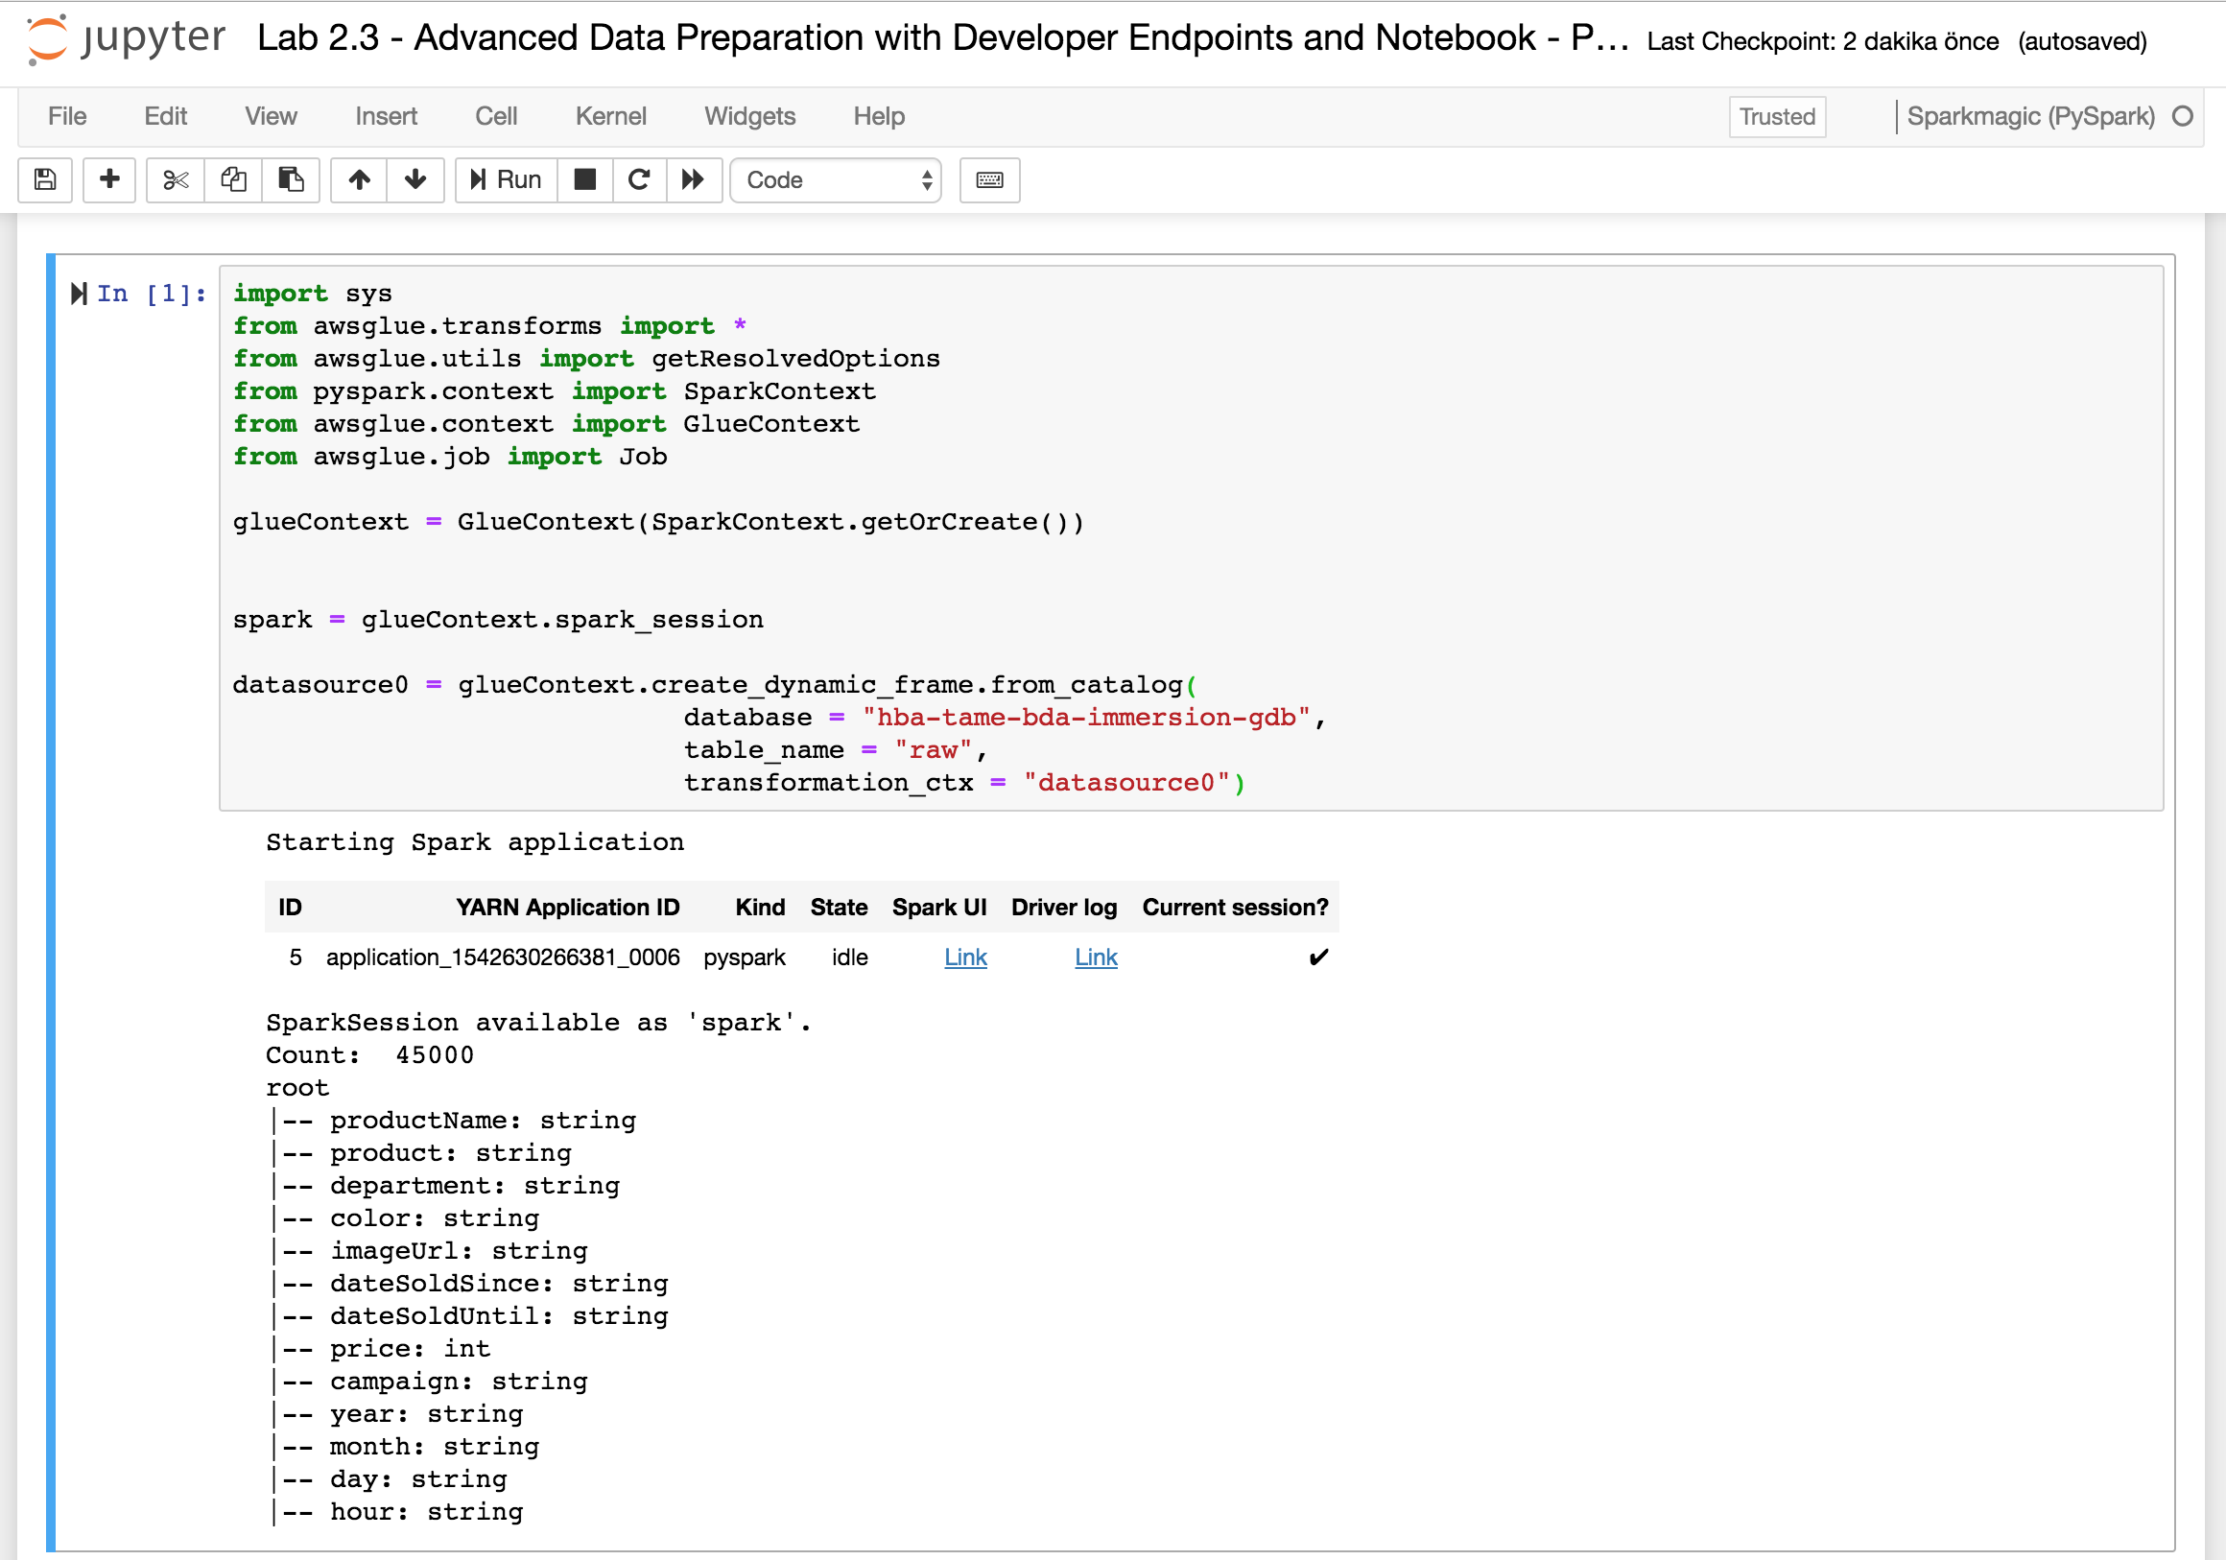

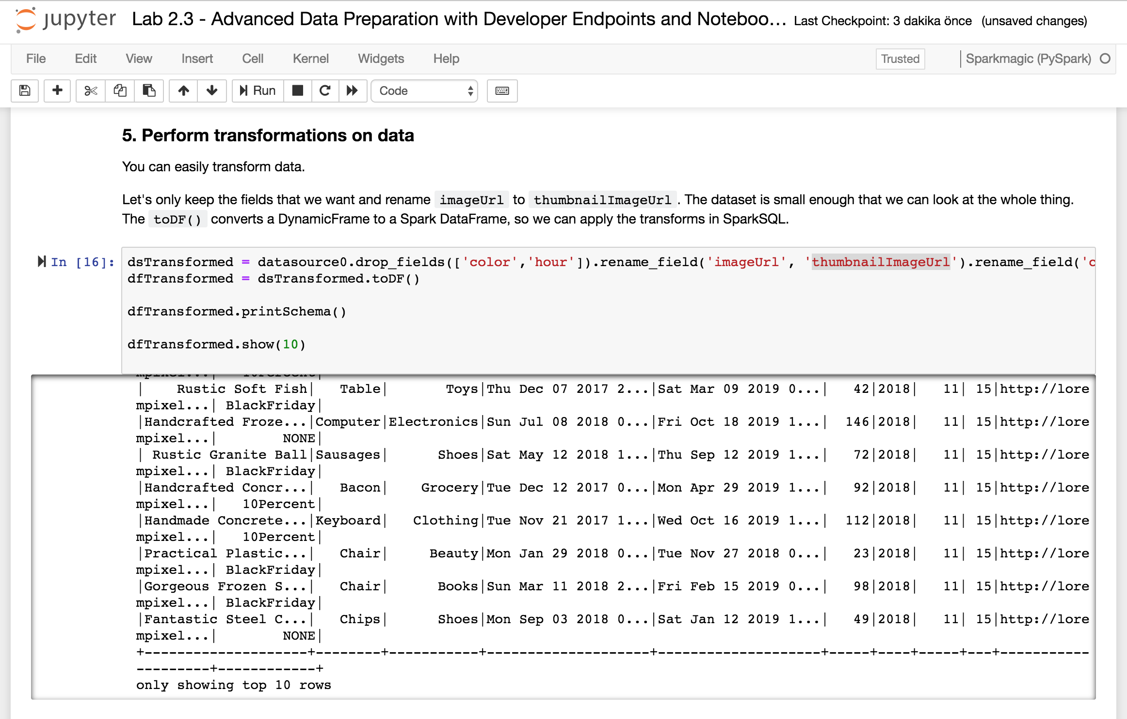

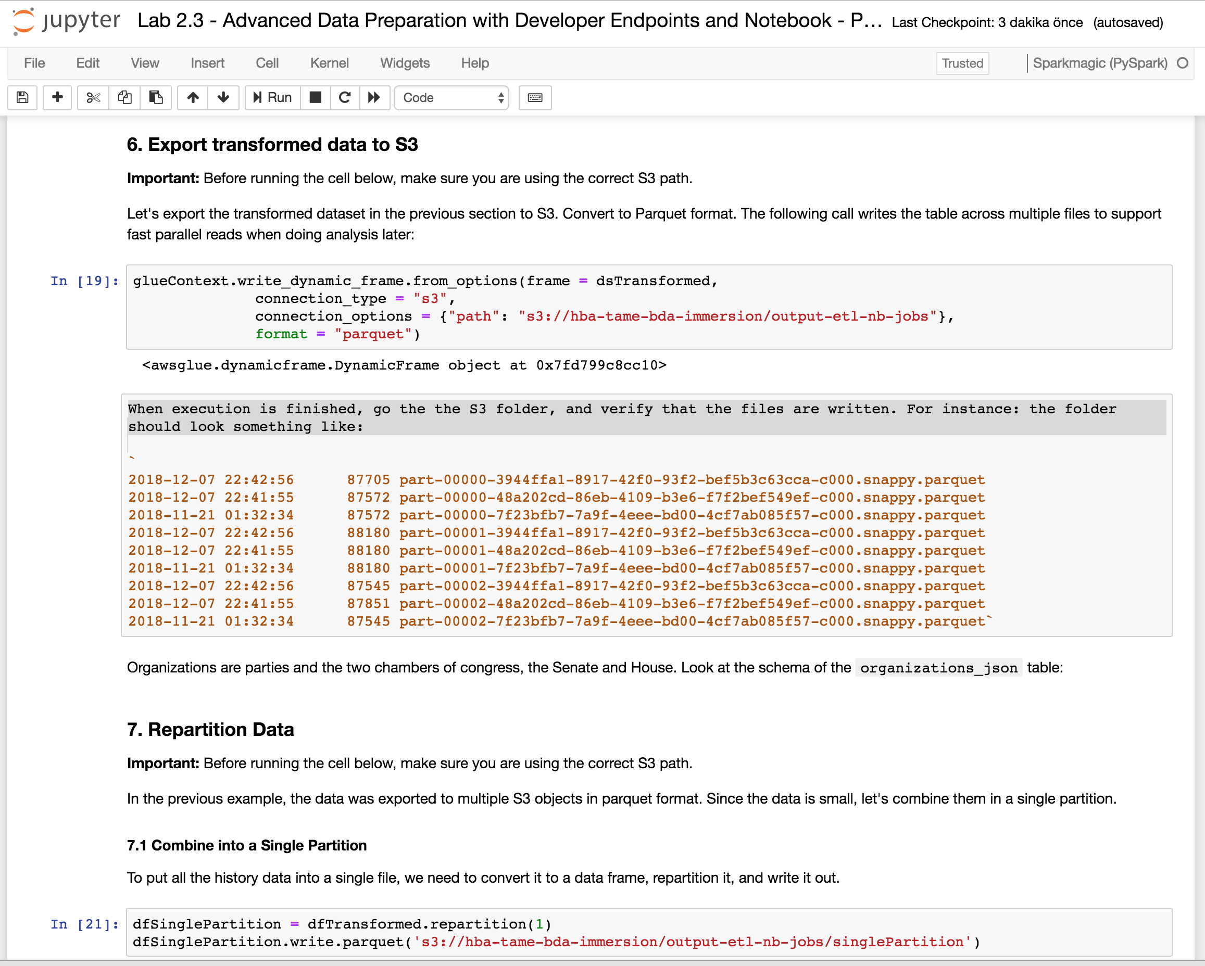

1. Check output data in S3:

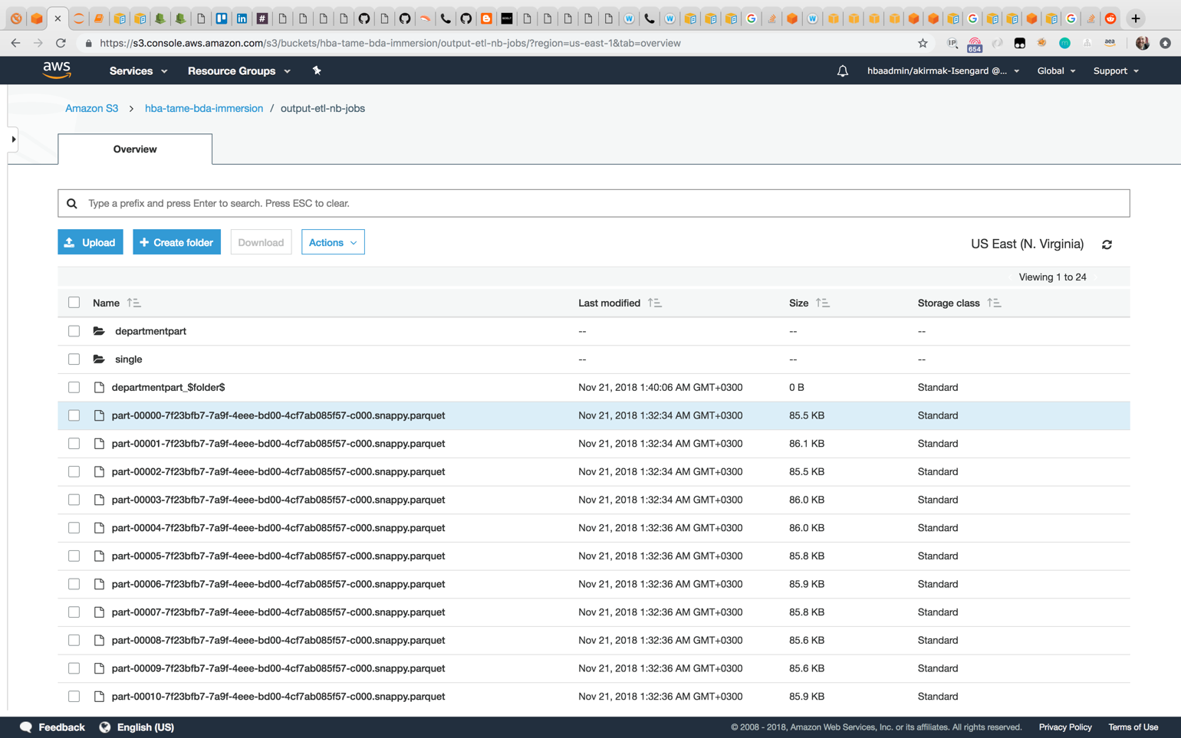

Data partitioned by department:

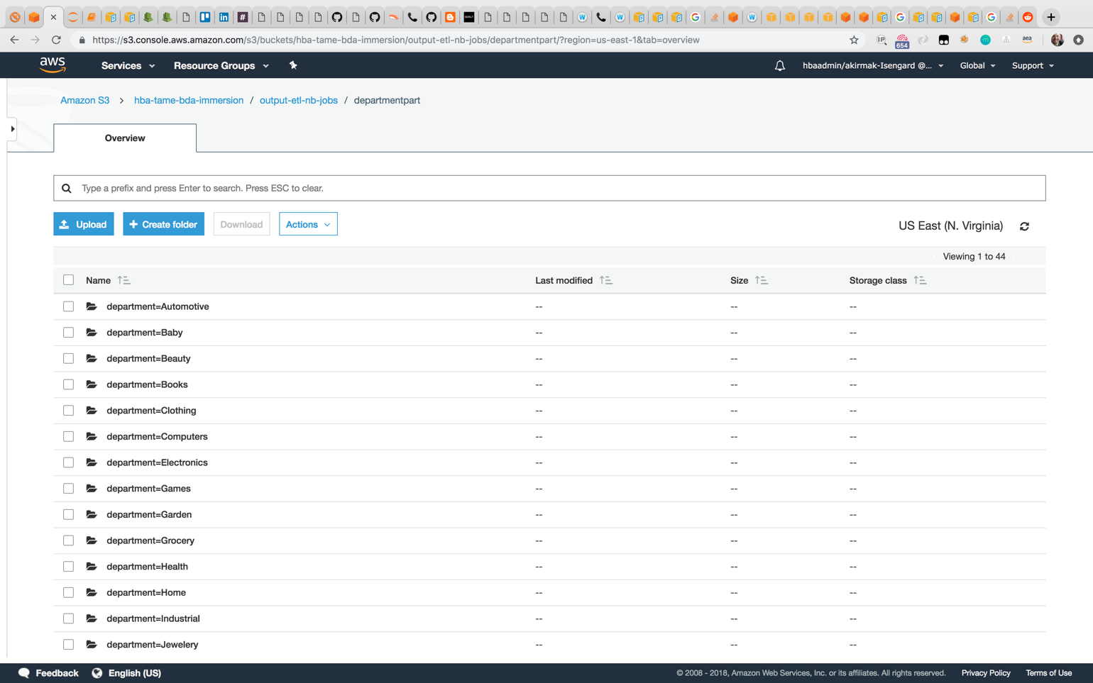

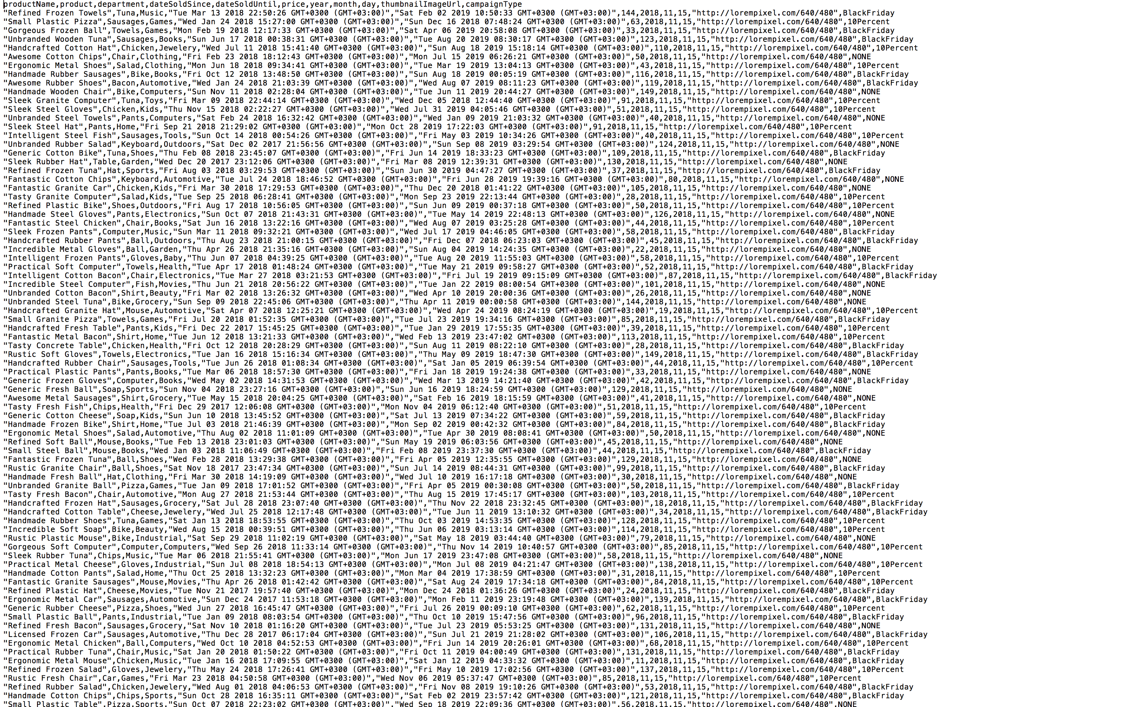

## Lab 2.3.1 Automating ETL Tasks with Triggers

In this lab, you will browse through the ETL automation capabilities provided by the Glue service. You won’t be doing hands-on exercise due to limited time. However, you are encouraged to explore it later, as all the configuration is in your own AWS account.

1. The Add Trigger looks like below. You first select the ETL job, which you’d like to add trigger. In this example, the trigger is scheduled to run daily.

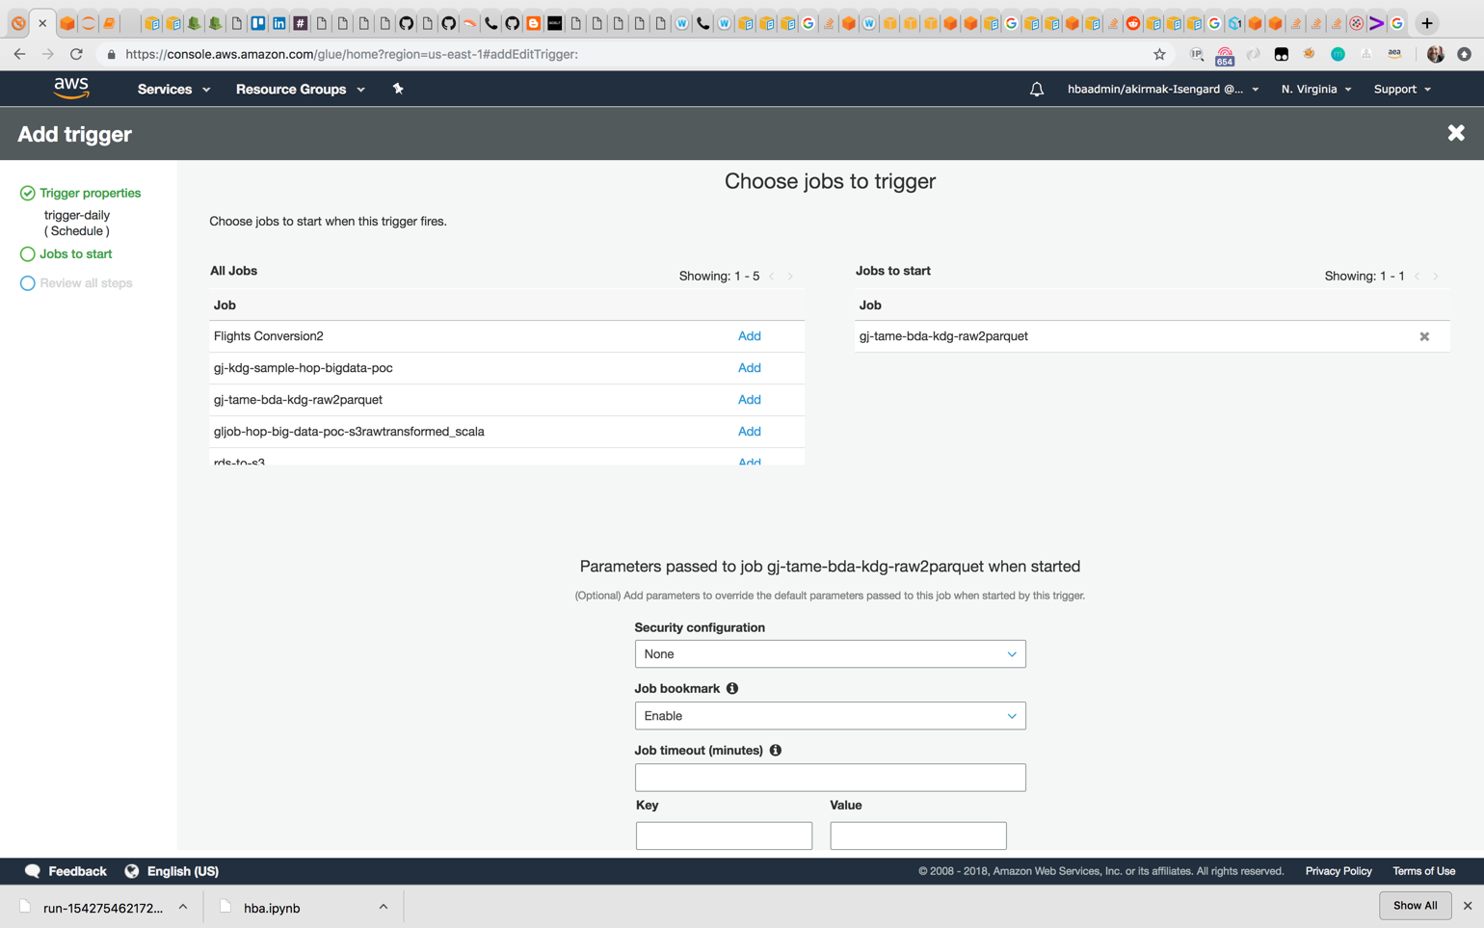

1. You can link multiple tasks to form workflows. In this case, you need to select Trigger type: “Job events”. You can select based on the status of the ETL job (e.g. succeeded, failed, stopped, timeout).

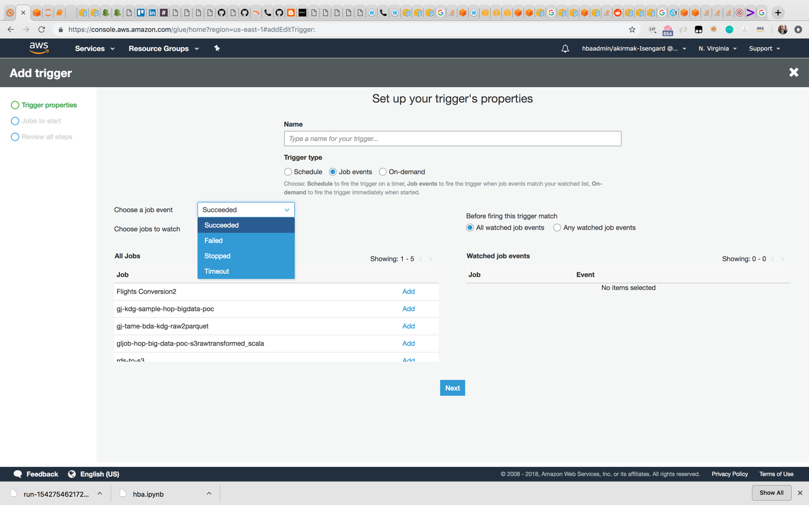

1. The ETL code we created in the previous lab is not prepared to be deployed as automated job, but if you had an advanced ETL job code, you prepared, you’d deploy it from the ‘Create job’ interface easily. The ‘Edit script’ gui would also render your code if you incldued the metadata in the code fields. You can include additioal libraries.

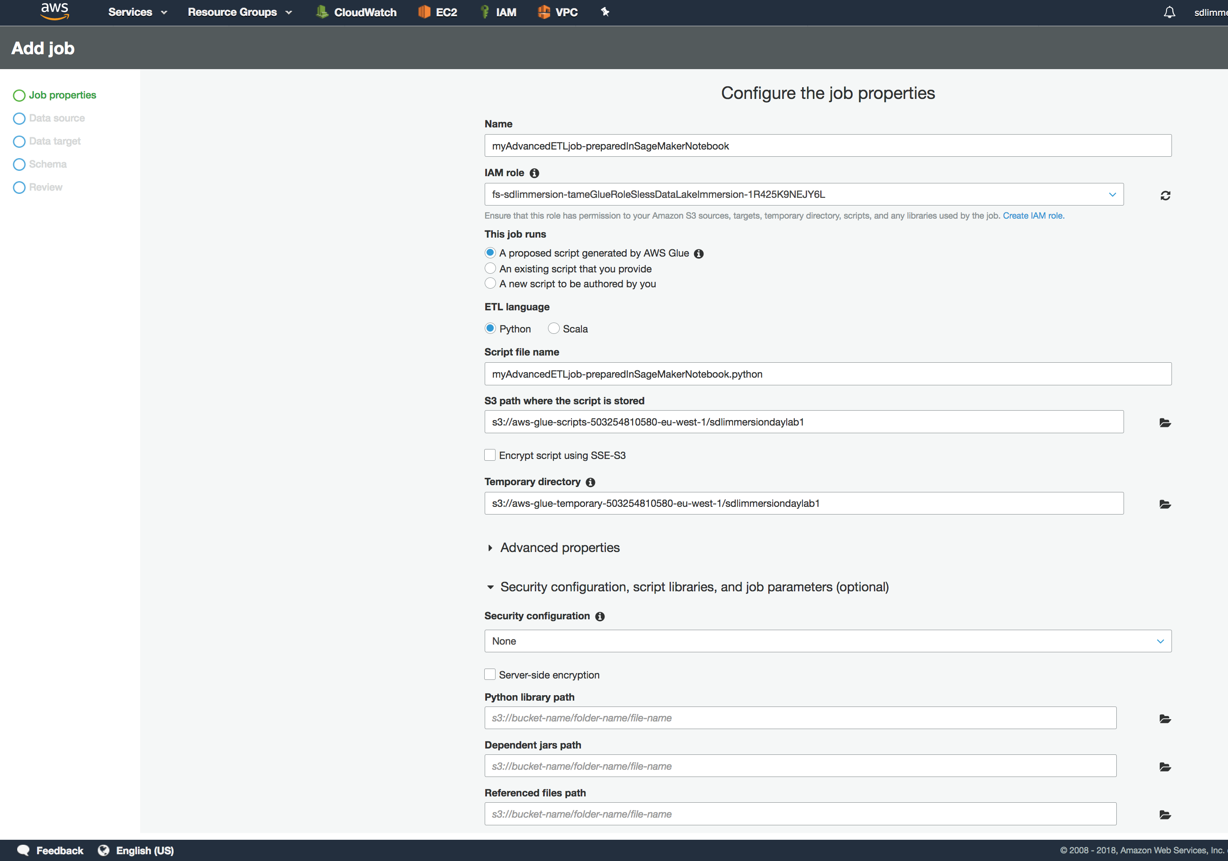

# Summary & Next Steps

Congratulations. You have successfully created an processing pipeline without clusters, which is ready to process huge amounts of data.

So, what’s next? Since the amount of data you processed in this lab was tiny, in the next lab, you will work with an open data set by first cataloging it using Glue, and querying using Athena.

# Deleting Lab Resources

If you won’t proceed to the next lab, make sure you terminate the resources below to avoid bills.

* Glue Service:
  + **Cost Warning: Glue Developer Endpoint:** Billing for a development endpoint is based on the Data Processing Unit (DPU) hours used during the **entire** time it remains in the **READY** state. **To stop charges, delete the endpoint**. To delete, choose the endpoint in the list, and then choose **Action, Delete**.
  + **You can delete the tables and databases created in the data catalogue.**
* SageMaker:
  + Make sure you delete the SageMaker notebook attached to the Glue Developer endpoint.
* S3:
  + Delete the buckets and the data inside.
* Firehose:
  + Delete the delivery stream
* IAM
  + **Security Warning:** For the sake of simplicity, some of the permissions in the examples below are a bit too permissive (for example, the IAM role defined for the sagemaker notebook has **s3FullAccess permissions. This is a configuration issue we will fix in the next version of the CloudFormation template**). The permissions shall either be removed for the user after the immersion day, or they shall be turned into more fine-grained permissions.

# Appendix A – Jupyter Notebook Code

The .ipynb file will be provided by your instructor separately.

|  |
| --- |
| import sys  from awsglue.transforms import *  from awsglue.utils import getResolvedOptions  from pyspark.context import SparkContext  from awsglue.context import GlueContext  from awsglue.job import Job  glueContext = GlueContext(SparkContext.getOrCreate())  spark = glueContext.spark_session  datasource0 = glueContext.create_dynamic_frame.from_catalog(  database = "<your initials>-tame-bda-immersion-gdb",  table_name = "raw",  transformation_ctx = "datasource0")  print "Count: ", datasource0.count()  df = datasource0.toDF()  df.printSchema()  df.show(5)  df.filter((df.campaign=='BlackFriday')).select('productName','product', 'department', 'price','campaign').show()  dsTransformed = datasource0.drop_fields(['color','hour']).rename_field('imageUrl', 'thumbnailImageUrl').rename_field('campaign', 'campaignType')  dfTransformed = dsTransformed.toDF()  dfTransformed.printSchema()  dfTransformed.show(10)  glueContext.write_dynamic_frame.from_options(frame = dsTransformed,  connection_type = "s3",  connection_options = {"path": "s3://<your initials>-tame-bda-immersion/output-etl-nb-jobs"},  format = "parquet")  dfSinglePartition = dfTransformed.repartition(1)  dfSinglePartition.write.parquet('s3://<your initials>-tame-bda-immersion/output-etl-nb-jobs/singlePartition')  dfTransformed.write.parquet(  's3://<your initials>-tame-bda-immersion/output-etl-nb-jobs/byDepartment',  partitionBy=['department'])  # [Optional] Write your query here |

# References

1. Website, AWS Data Lake, <https://aws.amazon.com/tr/big-data/datalakes-and-analytics/what-is-a-data-lake/>
2. Whitepaper, “Lambda Architecture for Batch and Stream Processing, AWS, October 2018, <https://d0.awsstatic.com/whitepapers/lambda-architecure-on-for-batch-aws.pdf>